Name of Activity: Career Counselling by TCS Achievers
Category: Seminar
Organizing Unit: IQAC and Placement Cell, RKSMVV
Date: 07.01.2023
Time: 01:30 PM
Venue: Swamiji Bhavan, RKSMVV
Number of Students: 150
Name of Resource person/s (with designation): Saptaparni Sarkar (TCS, Trainee BPS), Janayitri Mondal (TCS, Trainee BPS), Sabnam Khatun (TCS, Trainee BPS), Susmita Jana (TCS, Trainee BPS).
Brief Description of the Event:
This event has been a part of the Students’ Week celebration. In this event, students of our college who were already placed in TCS gave professional advice and shared their experiences with the present students about the job prospects of learning and work management. They helped present students by discussing different issues on career exploration, career choice/ flexibilities, career changes, lifelong career development and other career-related matters.
Programme Outcome:
This event helps the students to know and understand themselves the nature of job prospects and how they could be able to cope with the challenges in the fields of career, educational, and life decisions. Participants learn that choosing career options is a major decision after graduation.

‘Flyer:
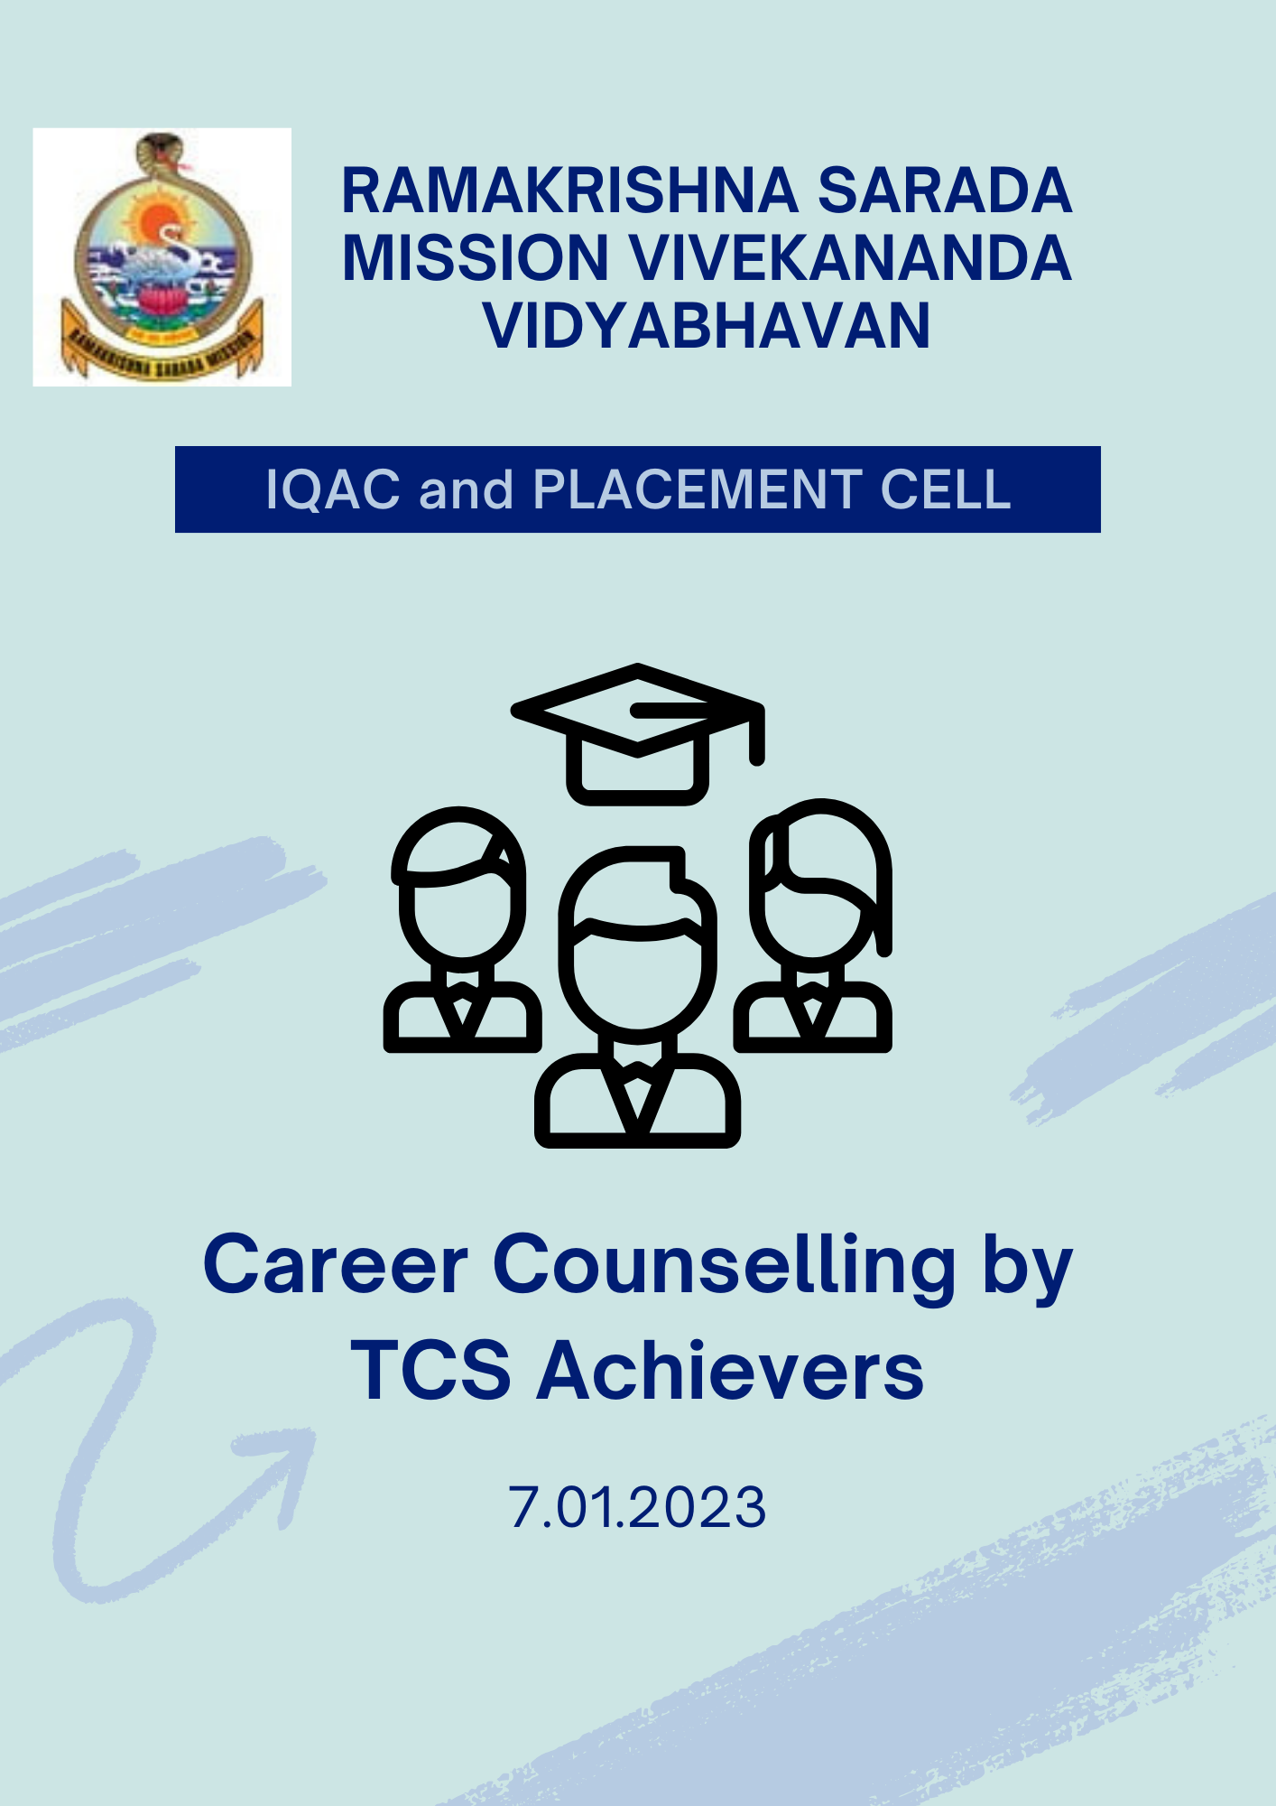
Geo-Tagged Photos:
