Name of the Activity: Samkhya Philosophy and Yoga Philosophy
Category: Extension Lecture
Organising Unit: Department of Education
Date: 8.2.2023
Time: 11 a.m. onwards
Venue: RKSMVV College Campus
Name of the Resource person/s with designation: Pravrajika Ishtatmaprana, Monastic Professor, Department of Philosophy, RKSMVV
Number of the Participants:13
Brief Description of the Event: Pravrajika Ishtatmaprana lucidly delivered a profoundly analytical lecture so that the students could understand the nuanced areas of the Samkhya darshan.
Programme Outcome: Samkhya teaches us about the components of the body, mind, and spirit, from the gross elements that make up the physical body to the more subtle elements of the mind and consciousness. Samkhya names each element, teaches us its function, and shows us the relationship each element has to all others. Similarly, even if one Philosophy of yoga is understood and practised sincerely, real yoga or union could be experienced. Yoga Philosophy offers a secondary sense of perspective and a strong base to understand the meaning of life and help one replace the non-essential parts of life with meaningful practices. The students gained insights into Samkhya and Yoga Philosophy and their importance in education. And our very own Pravrajika Ishtatmaprana explained the whole thing so beautifully in a short time.
Flyer

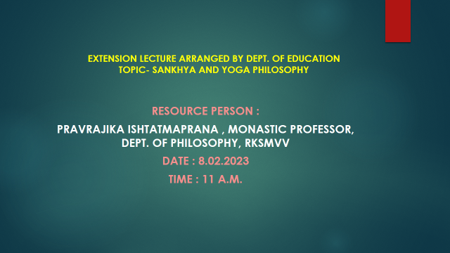
Geo-tagged Photos:

