

**RAMAKRISHNA SARADA MISSION VIVEKANANDA VIDYABHAVAN**

**DEPARTMENT OF PHILOSOPHY**

**PLACEMENT OF STUDENTS**

|  |  |  |  |
| --- | --- | --- | --- |
| **ACADEMIC YEAR** | **YEAR OF PASSING** | **PLACEMENT OF STUDENTS IN GOVT SECTOR** | **PLACEMENT OF STUDENTS IN NON- GOVT SECTOR** |
| **2016-2019** | **2019** | **1** | **3** |
| **2017-2020** | **2020** | **1** | **1** |
| **2018-2021** | **2021** | **x** | **2** |
| **2019-2022** | **2022** | **x** | **4** |
| **2020-2023** | **2023** | **x** | **7** |

**STUDENT EMPLOYMENT 2018-2024**

|  |  |  |  |
| --- | --- | --- | --- |
| SL. NO. | NAME | PLACEMENT ORGANIZATIONS | SALARY |
| 1 | ANTIKA SARKAR | TECH MAHINDRA | 1,20,000/-per year |
| 2 | NABANITA GHOSH | CONNEQT BUSINESS SOLUTIONS | 1,20,000/-per year |
| 3 | MOUMITA BISWAS | HDB FINANCIAL SERVICES LTD. | 1,41,600/ per year |
| 4 | SUNITA HEMBROM | TECH MAHINDRA | 1,20,000/- peryear |
| 5 | CHANDRIMA PONDIT | TATA CONSULTANCY SERVICES | 10,250/- per month |
| 6 | PIU ROY | TATA CONSULTANCY SERVICES | 10,560/- per month |
| 7 | SUKLA DAS | ASSISSTANT PROFESSOR MALDA COLLEGE(JOINED SINCE 2021) | 84168/- per month |
| 8 | PUJA SAHA | TCS (JOINED SINCE 9.11.22) | 60, 000/- per month |
| 9 | MITHU DAS | SUPPORT EXECUTIVE, SARNA INFOCOM PVT. LTD. (JOINED SINCE 10.4.23) |  |
| 10 |
| PUJA MONDAL | BRANCH SALES EXECUTIVE, BANDHAN BANK (JOINED SINCE 28.3.23) |  |
| 11 | RINITA MUKHERJEE | HDFC BANK, Customer Care Executive | 18,065/- per month |
| 12 | SUPRIYA MONDAL | Works at RKSMVV Office |  |
| 13 | ANANYA DEY | Executive, Department of Guest Relations at SRM Institutes of Medical Science, Chennai. | Rs. 2,47344/- per year |
| 14 | Priya Dey | PART-TIME TEACHER |  |
| 15 | Urmila Das | Cashier, Ujjivan Pvt. Bank, since 15.2.2022, | Rs. 2,82,132/-, per year |
| 16 | MOLI DAS | Telecaller, HDB Finacial Services Ltd., since 21.6.22  Salary | 1,45,272, per year |
|  | Priyanka Guin | Tata Consultancy Service | 10,250/- per month |
| 18. | Rini Hazra | Dhakuria Ramchandra High School | 10,000/- per month |
|  | Subharchita Mukherjee | Works at Nabadwip and Krishna Nagar Judge Court |  |
|  | Shima Joddar | Resource Person, Value Education Department (Since 1.7.23), at RAMAKRISHNA MISSION VIVEKANANDA INSTITUTE OF VALUES, NEW DELHI |  |  |
|  | Shreshtha Ghosh | Works at west Bengal Police since March 2024 | 30,432/- per month |  |
|  | BINA BALI | Food &Supplioes, Govt. Of West Bengal | 12714/- per month |  |

**JRF Scholarship**

|  |  |  |  |  |  |  |  |  |  |
| --- | --- | --- | --- | --- | --- | --- | --- | --- | --- |
| SL. NO. | NAME | | PASS OUT | | NET/SET/JRF | INSTITUTION | | SCHOLARSHIP AMOUNT | |
| 1. | | Swapna Sarkar | 2018 | JRF NET 2022 | | | West Bengal State University | | 46990/- per month |
|  | | Pallabi Mondal | 2019 | JRF NET 2020 | | | Jadavpur University | | 48,990/- per month |

Dr. Bidisha Chatterjee

HOD

DEPARTMENT OF PHILOSOPHY

**:**

**DOCUMENTS**

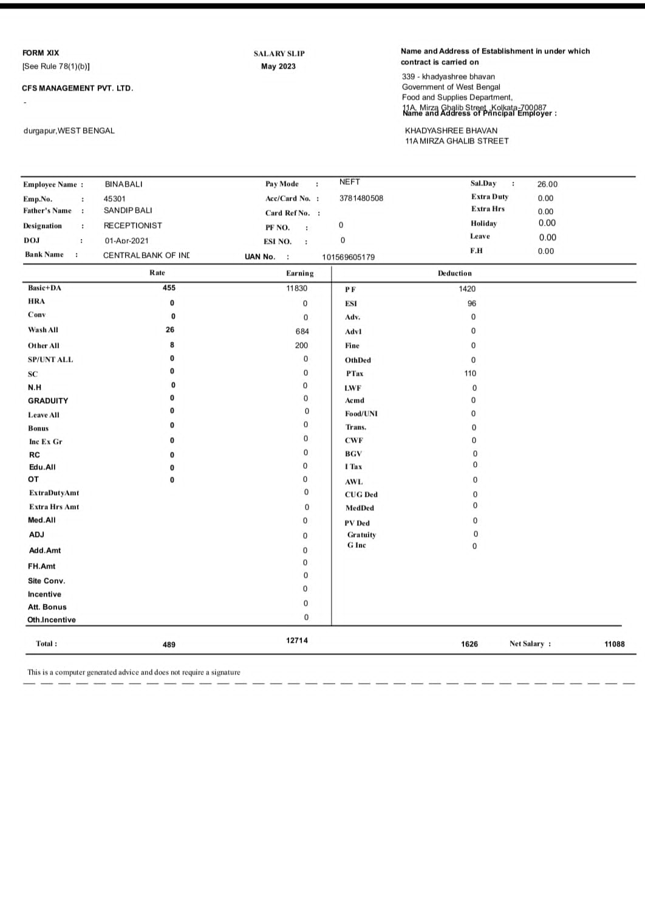

**BINA BALI**

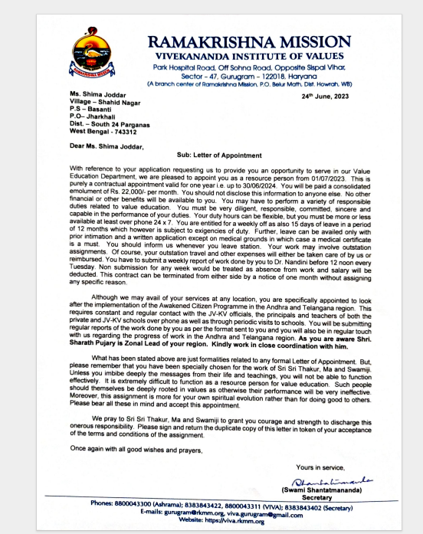

**SHIMA JODDAR**

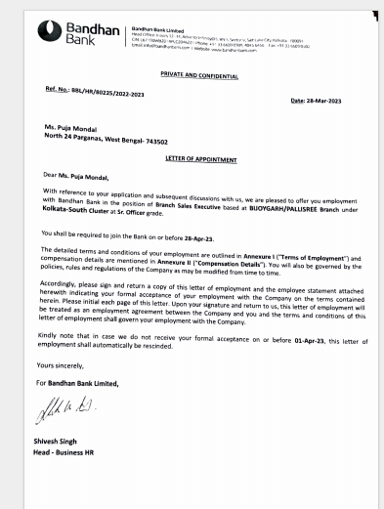

**PUJA MONDAL**

**ANANYA DEY**

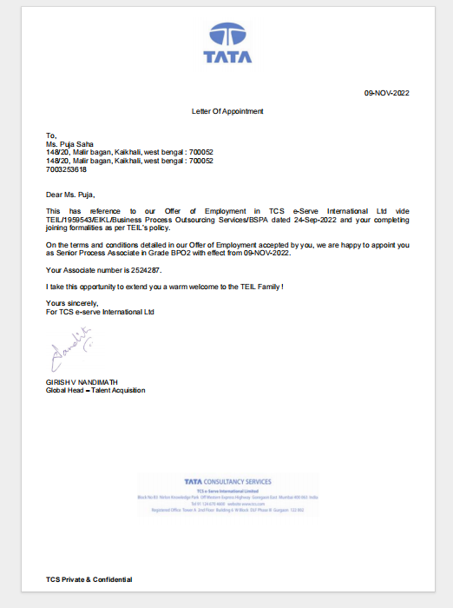

**PUJA SAHA**

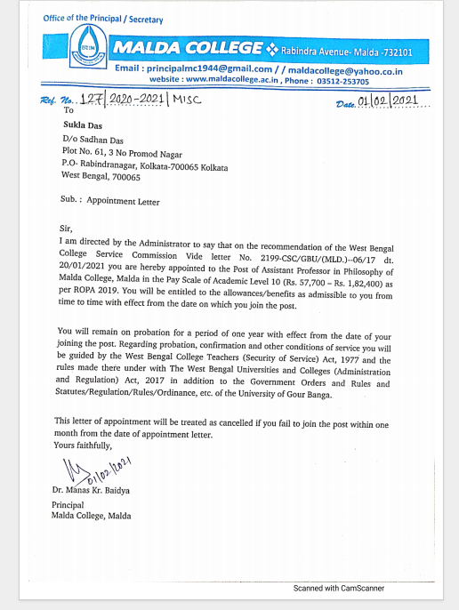

**SHUKLA DAS**

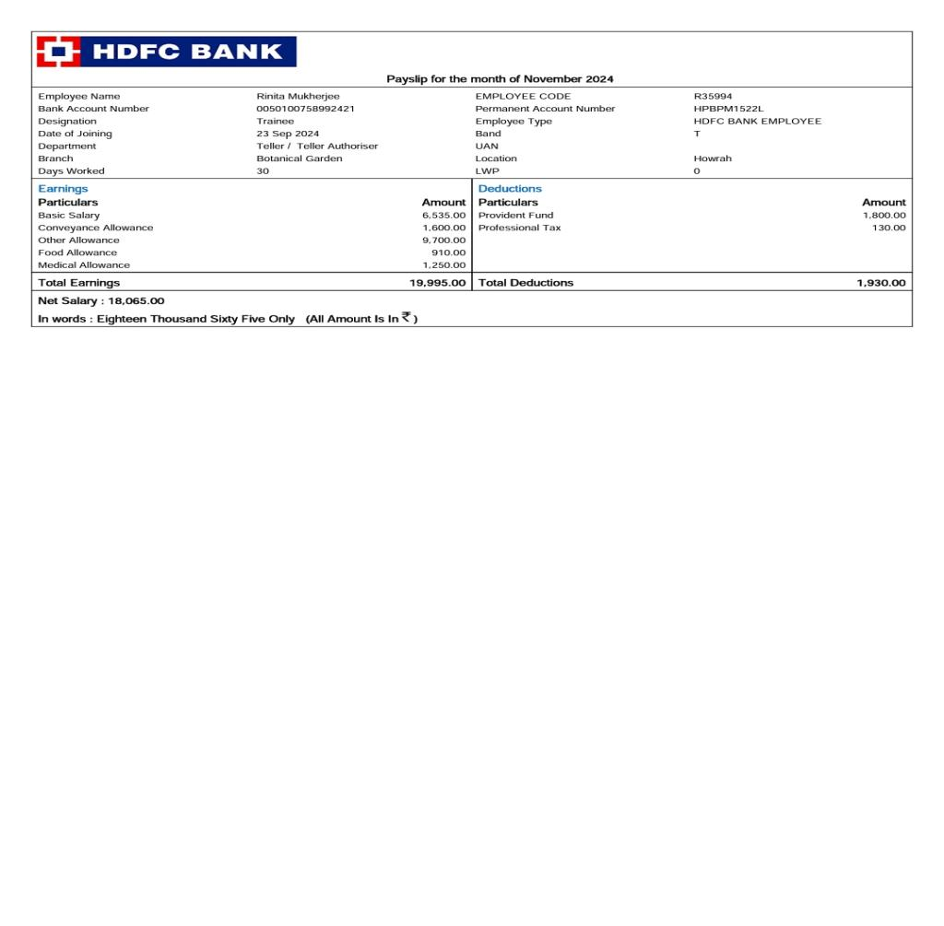

**RINITA MUKHERJEE**

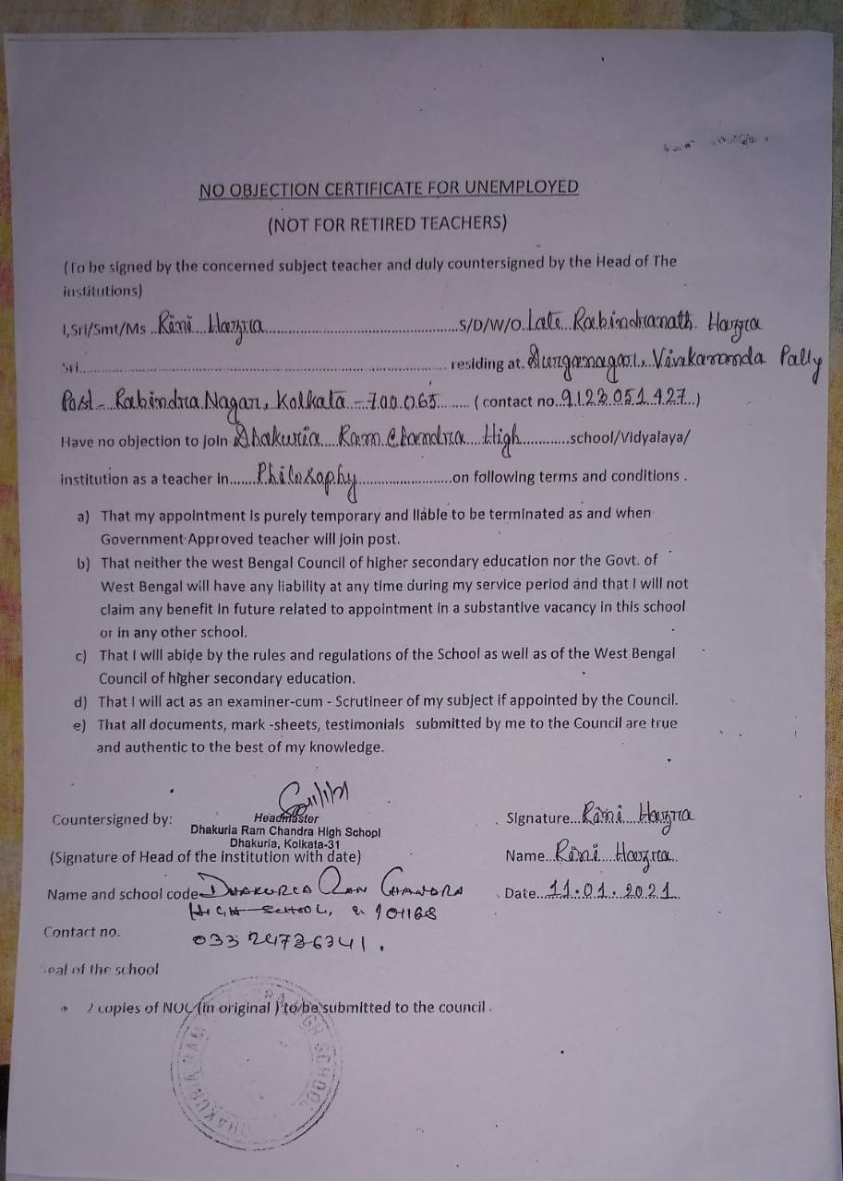

**RINI HAZRA**

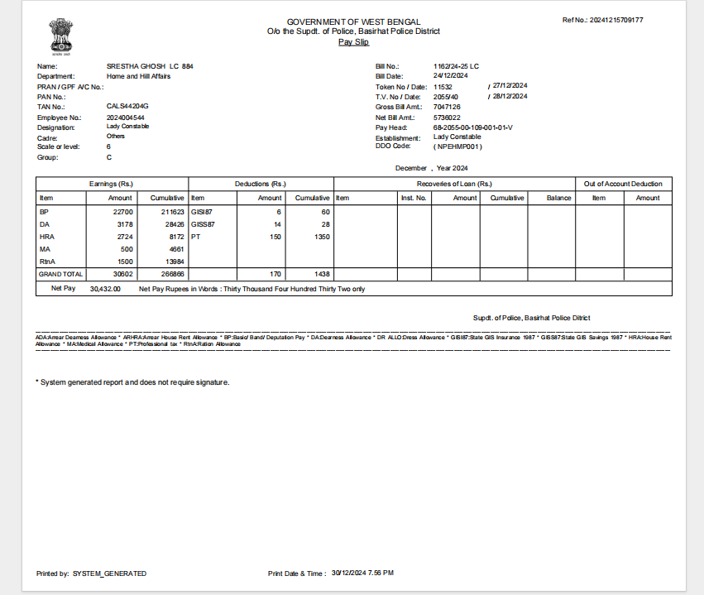

**SHRESHTHA GHOSH**

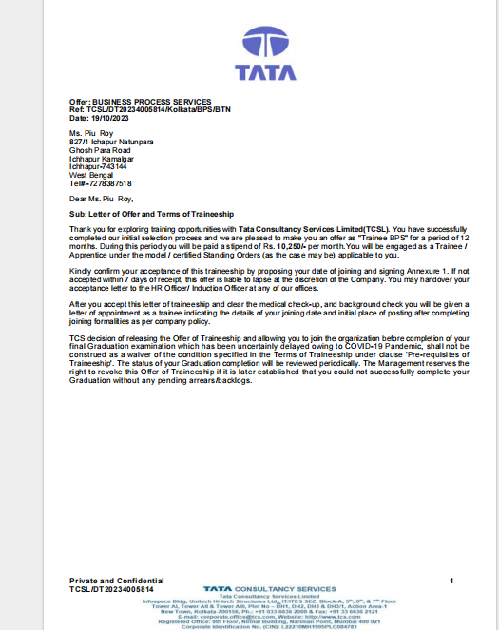

**PIU ROY**