STUDENT’S ACTIVITY

Our ex- students of PG course, Rini Hazra was invited to deliver a lecture at Scottish Church College on 29.4.22. She gave a lecture and PPT presentation on Animal Ethics.

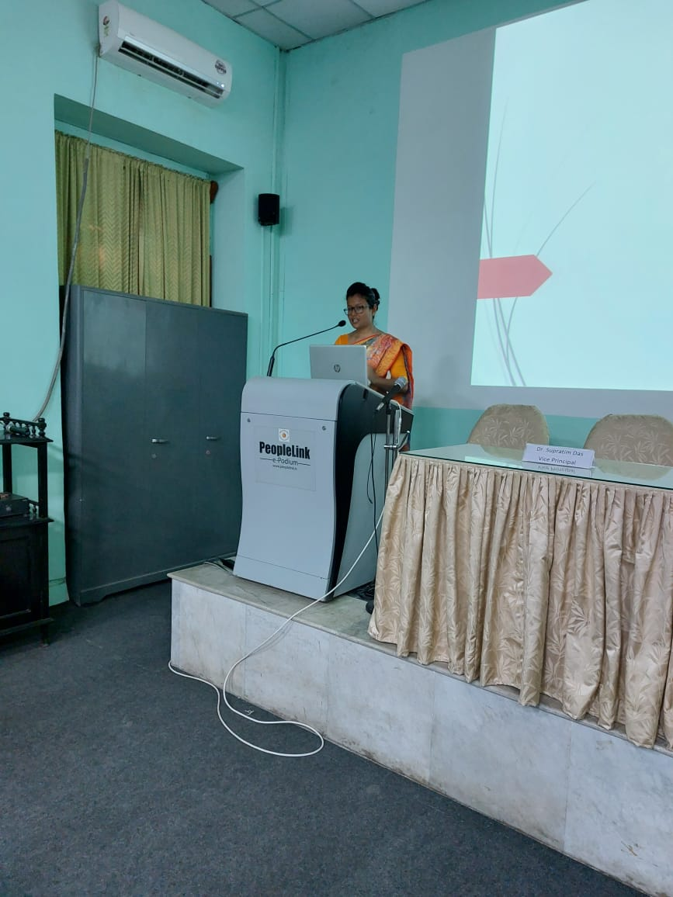

**RINI HAZRA, POST GRADUATE EX-STUDENT OF DEPARTMENT OF PHILOSOPHY, RAMAKRISHNA SARADA MISSION VIVEKANANDA VIDYABHAVAN, PRESENTING A PAPER ON ANIMAL ETHICS AT SCOTTISH CHURCH COLLEGE**

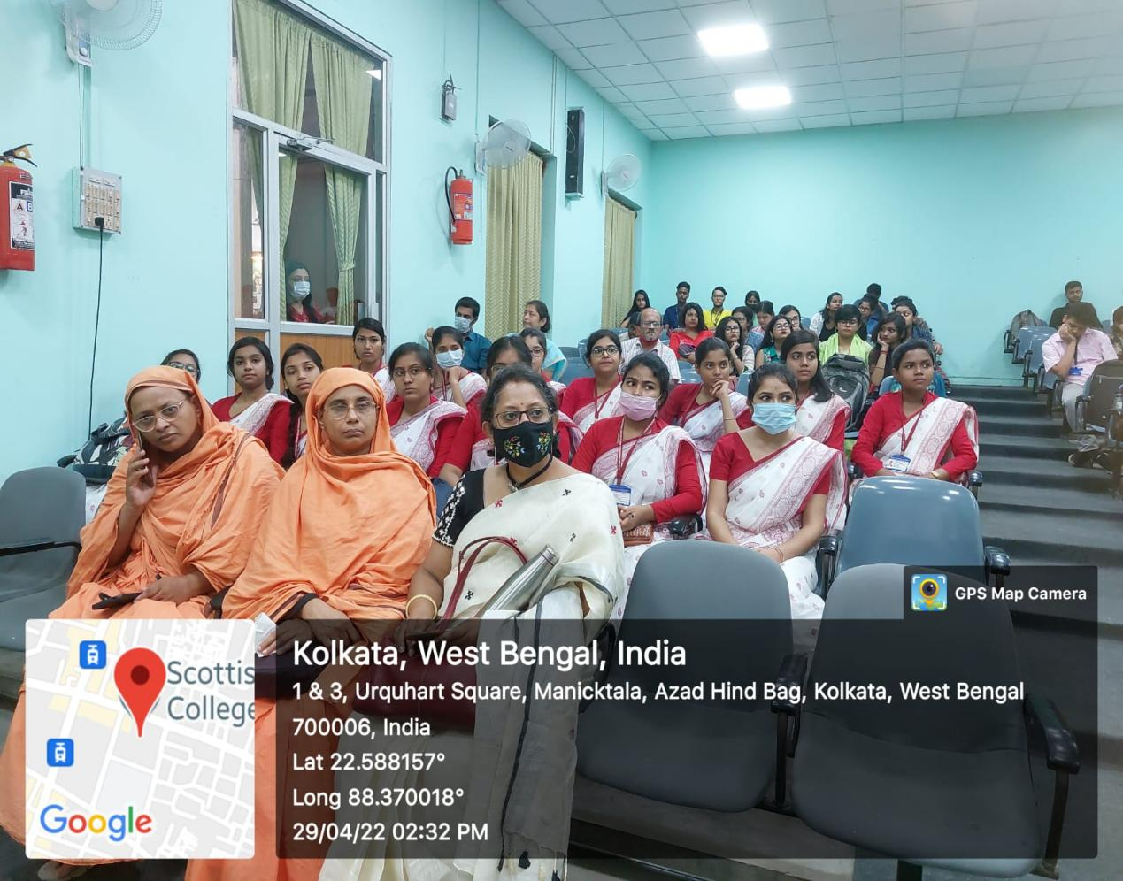

**Students and Teachers of Ramakrishna Sarada Mission Vivekananda Vidyabhavan attending the Student seminar at Scottish Church College.**

Parampara - the tradition of disseminating knowledge …

The ex-students of Post Graduate students and the present PG students are invited to take Parampara Classes for UG students. This tradition has been introduced by our department since 2023.

INAUGURAL SESSION OF PARAMPARA SESSION ON SEPTEMBER 2023

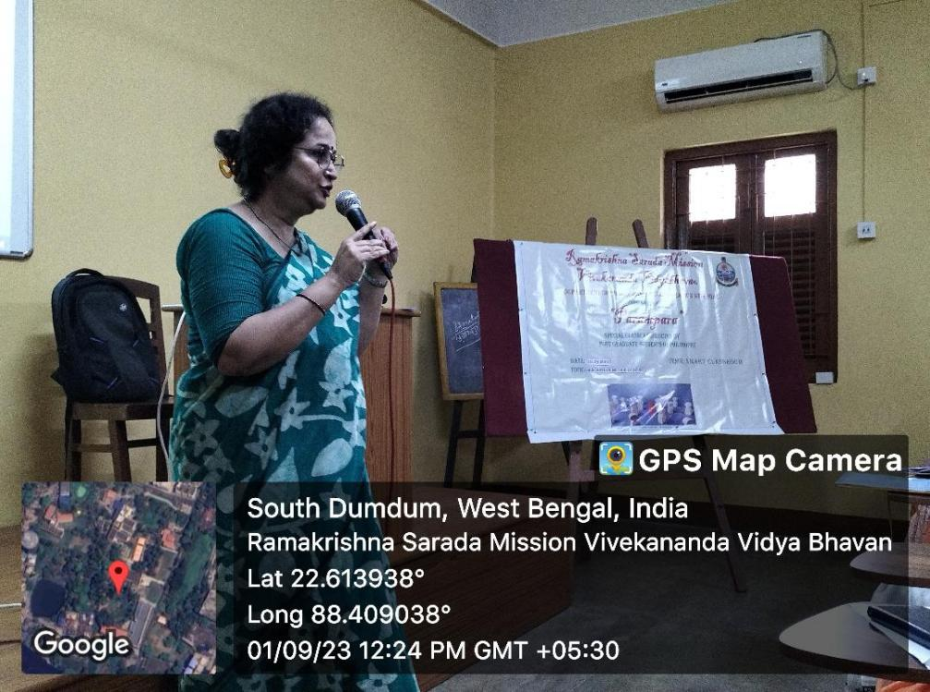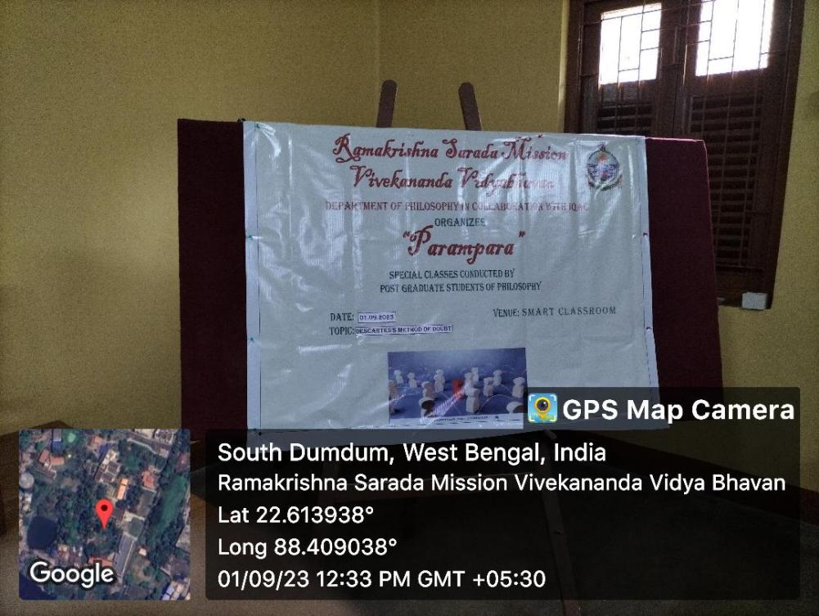

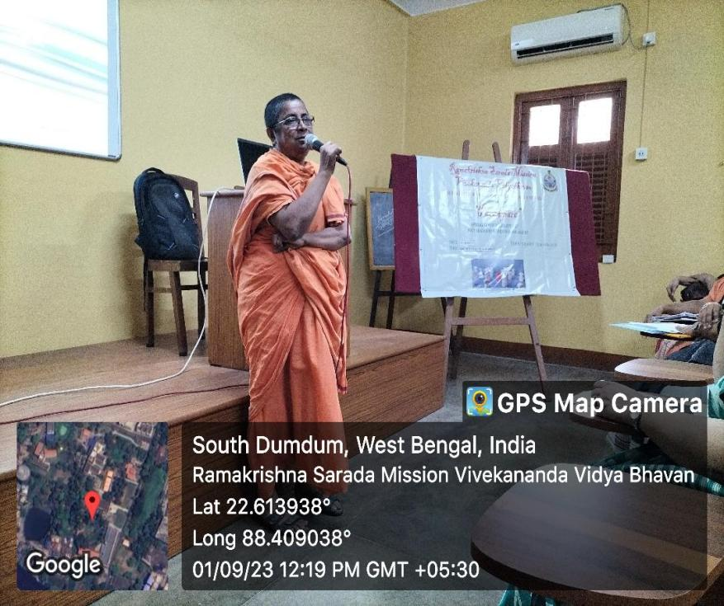

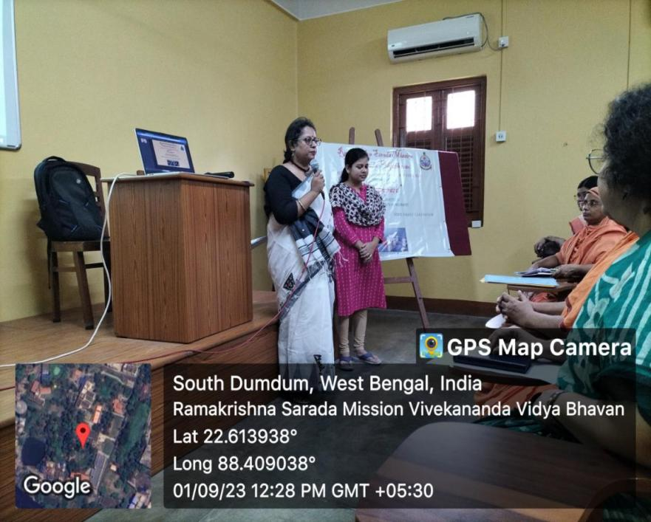

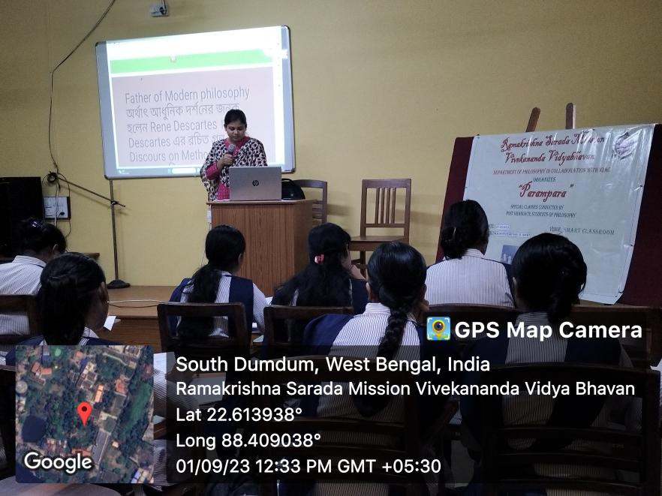

**Event: PARAMPARA**

**Name of the Topic** – Descartes’ Method of Doubt

**Date**: 1.9.23

**Venue**: Smart Classroom

**Speaker:**Arifa Khatun (Ex-student of RKSMVV)

**Number of Participants**: 25

The Department Of Philosophy introduced Parampara session from 1st September, 2023 . In the inaugural session, our Principal, Pr. Vedarupaprana delivered a thoughtful speech on the vision of ‘Parampara’ where our ex-students deliver lectures to spread their philosophical notions, outlook and understanding among the young learners. It was followed by an encouraging lecture by our IQAC coordinator,

Dr. Chaiti Mitra. Then, the co-convenor of the program, Dr. Bidisha Chatterjee, of the Department of Philosophy introduced the theme of Parampara. The speaker in the first session was Arifa Khatun, ex-student of RKSMVV delivered a lecture on

‘DescartesMethod of Doubt’.

**Brief Description:**

**Programme Outcome:** The Semester I students and the Post Graduate Students were present in the session and they had an interactive session with the speaker.

**Event*:* PARAMPARA (Lecture No. 2)**

**Topic: Indian Philosophy, Sankhya Darsana**

**Date**: 29.9.23

**Venue**: Smart Classroom No. 8

**Resource Person: Hritu Mukherjee**

**No. of Participants**: **5th Semester Students**

**Brief Description:**

The 5th semester students of Department of Philosophy attended the **Parampara** Class on 29.9.23. the speaker, Hritu Mukherjee delivered an excellent lecture on Sankhya Darsana. She explained the topics in details for clear understanding.

**Programme outcome:** The students were very much benefited from the inter-active session. They cleasrd their doubts regarding various issues and a brief notes was also given to them by the speaker.

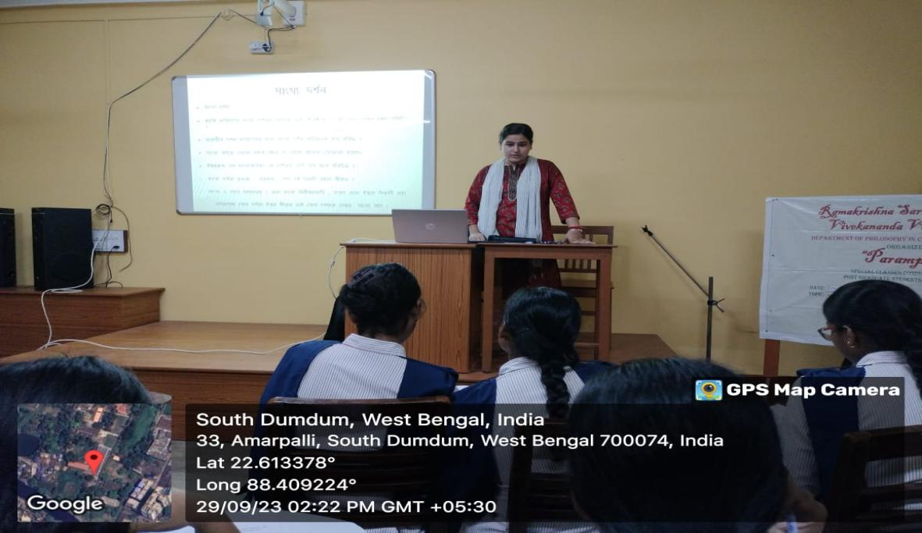

***PARAMPARA LECTURE NO.:2***

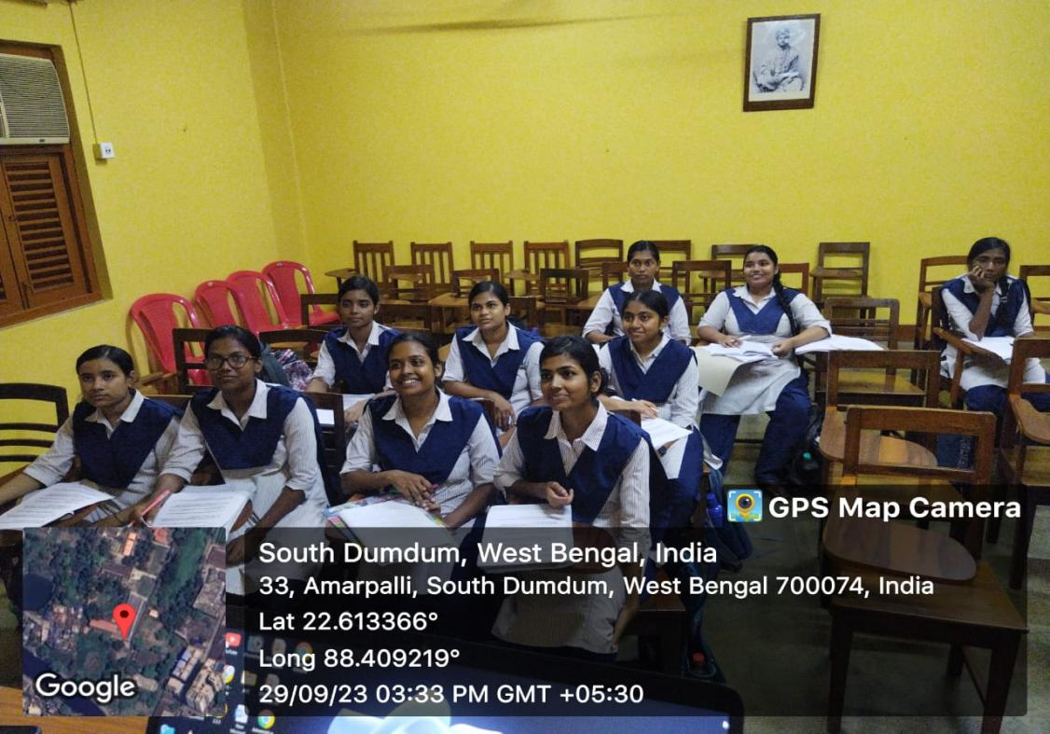

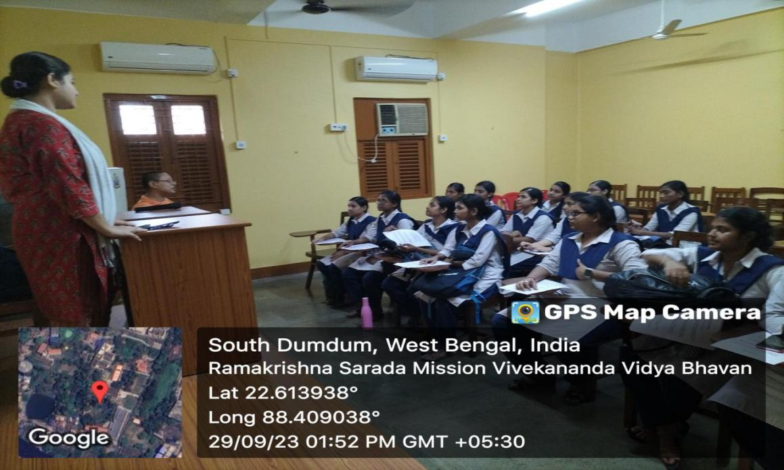

**Event*:* PARAMPARA (Lecture No. 3)**

**Topic:** Hospers on Ambiguity

**Date**: 24.11.23

**Venue**: Smart Classroom No. 8

**Resource Person: Hritu Mukherjee**

**No. of Participants**: **5th Semester Students**

**Brief Description:**

The 5th semester students of Department of Philosophy attended the **Parampara** Class on 29.9.23. the speaker, Hritu Mukherjee deliverde an excellent lecture on the critical concept of ambiguity as depicted by Hospers and its different implications.

**Programme outcome:** The students were very much benefited from the inter-active session as they were asked to solve few words of ambiguity and give proper explanation against it.

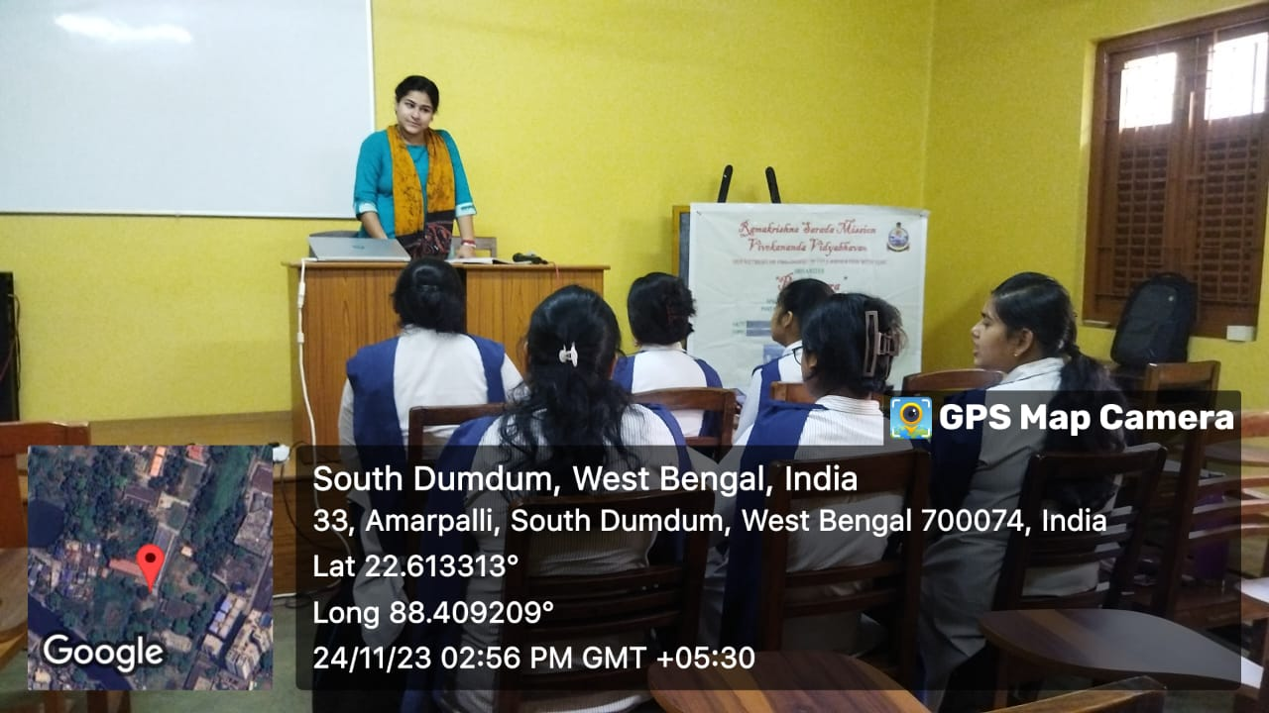

***PARAMPARA - LECTURE***

**Event:** Parampara class

Date: 1.3.24

Speaker; Hritu Mukherjee

Topic: A Critical Reflection on Leibnitz’s theory of Substance and Knowledge

Participants: Semester I students(10)

**Brief Description:** Hritu Mukherjee delivered an excellent lecture on the substance theory of Leibnitz. The Ist year students had an inter-active session with her.

**Outcome:** It is always a proud moment for the faculty members of the department to see that their ex-students are teaching their current fellow-beings.

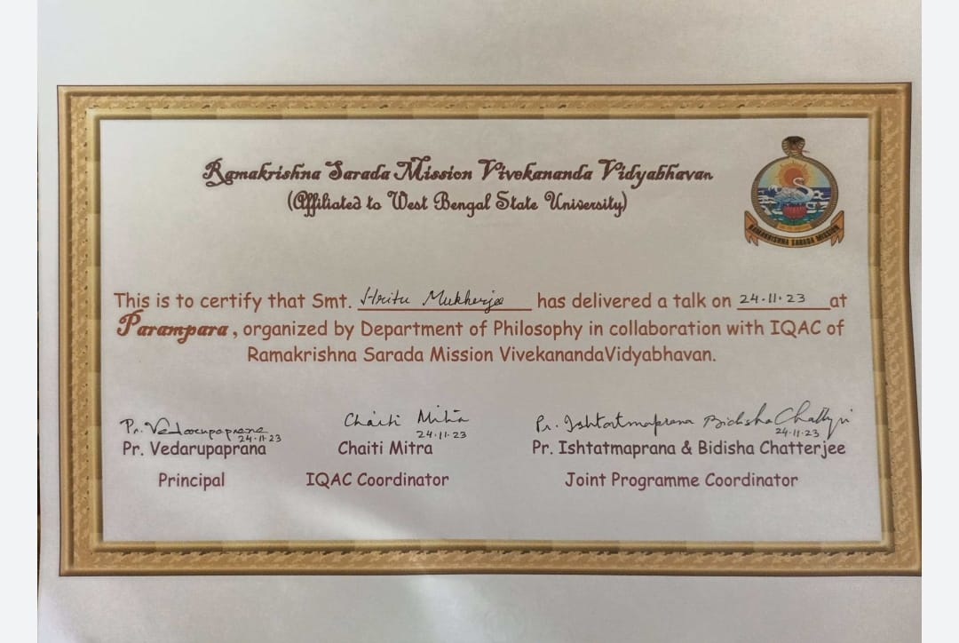

**Event: Parampara** lecture

**Date:** 15.3,24, 22.3.24, 5.4.24 and 13.4.24

**Topic**: A Critical Reflection on Hosper’s Theory of Knowledge

**Speaker: Pallabi Mondal**

**Brief Description:** Smt. Pallabi Mondal was the invited speaker in the Parampara session. She spoke on Hosper’s theory of knowledge. Semester V students attended the class.

**Outcome:** the students of Semester VI got the opportunity to have an inter-active series of lectures from one of our brightest studnent’s Pallavi Mondal, a JRF scholar mow attached with Jadavpur University.

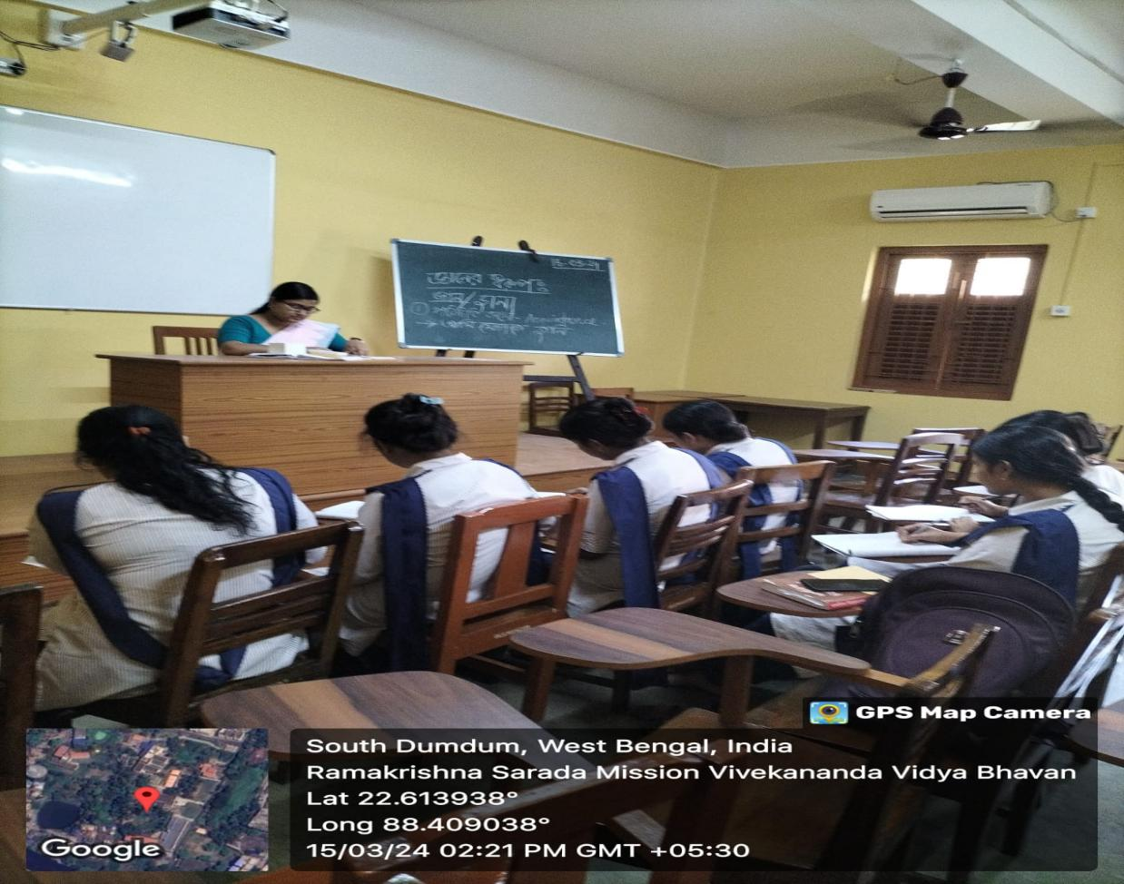

**Event: Parampara** class

**Date: 5.4.24**

**Topic** Karana

**Speaker:** Usha Hazari

**Participants:** Semester 4 students( 14)

**Brief Description:** Usha Hazari delivered an excellent lecture on karana in the Parampara lecture session. She expalined the intricate logical reasoning in a very lucid manner. The class benefited the students immensely.

**Outcome:**

The students got the opportunity to listen to an excellent demonstrative class from Usha.

