Name- Srijani
Category - Mobile photography
Organizing unit- Cultural Sub-Committee
Date – 20th November, 2022
Time – 2.30 pm
Number of students-28
Number of Teachers/Resource Person – 4
Number of beneficiaries – 5 (1st – 2, 2nd – 2, 3rd – 1)
Description of the event – A mobile photography competition was organized by Cultural sub-Committee. Subjects were AUTUMN and KOLKATA STREETS. Students were asked to submit photographs related to the subject by 20th November, 2022. Students were given the choice to select any one or both the subjects for photography, however, number of entries per competitor was restricted to 2 only. 28 students had participated in the event and there were 4 judges. They were also asked to provide a caption of the photograph. Total beneficiaries were five, where two students named Riyanka Mondal, History Dept, semester 5 and Swastika Biswas, Bengali Dept, semester 3 jointly stood first, two students named Bidisha Roy, Journalism and Mass Communication Dept, semester 5 and Abanti Mukherjee, Economics Dept, semester 3 jointly stood second and one student named Indrani Das Mahapatra, History Dept, semester 5 stood third.
Outcome
- Mastery over the device to use it as a medium to clearly communicate the content and context of their work visually and in writing.
- Skill enhancement and talent showcase.
Photographs: Prize Winning Photographs
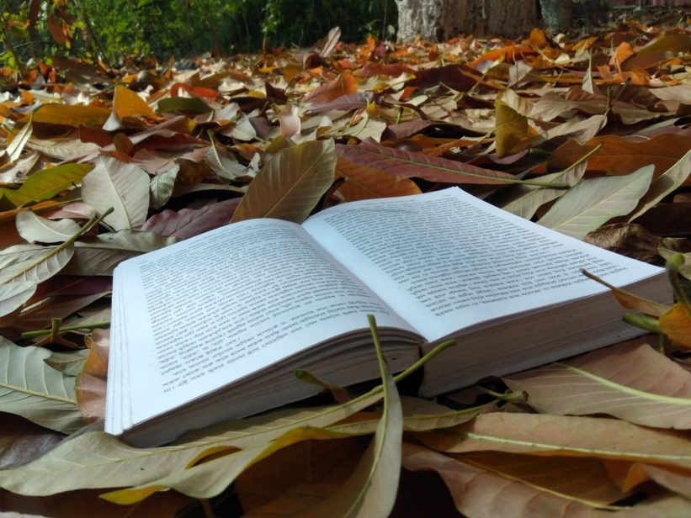
Patton ka hain jism janam (Joint 1st - Riyanka Mondal)
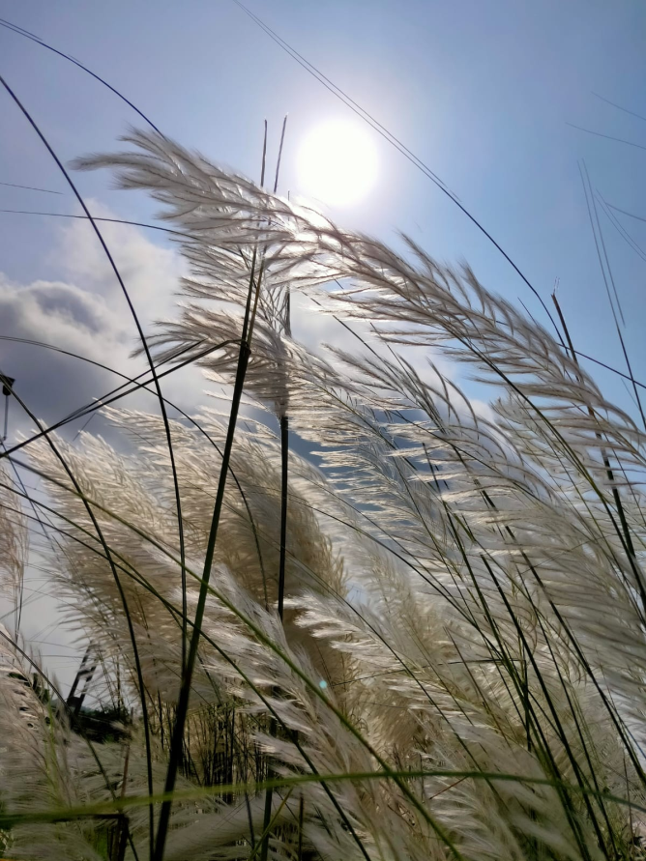
The Beauty of Autumn (Joint 1st - Swastika Biswas)
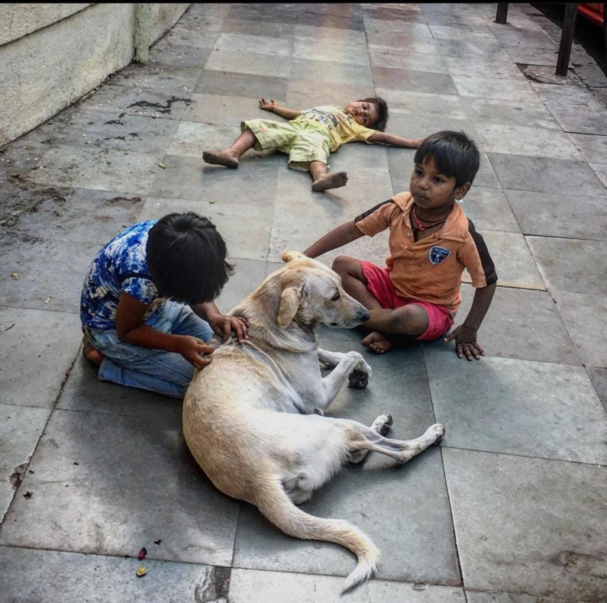
Sishu Moner Saralata / Simplicity of Children’s Mind (Joint 2nd - Bidisha Roy)
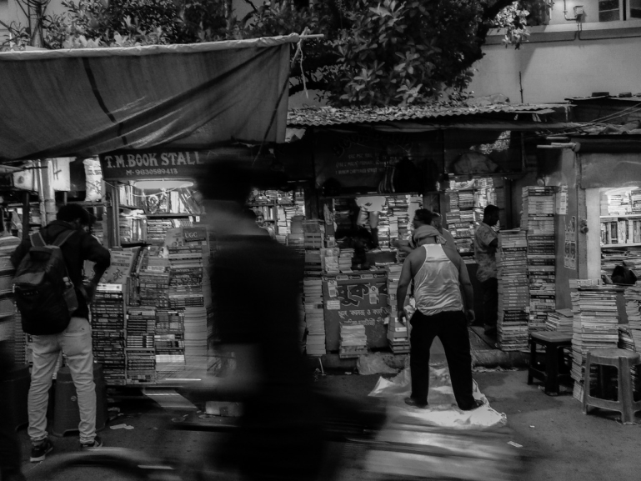
Haze of Grey (Joint 2nd - Abanti Mukherjee)
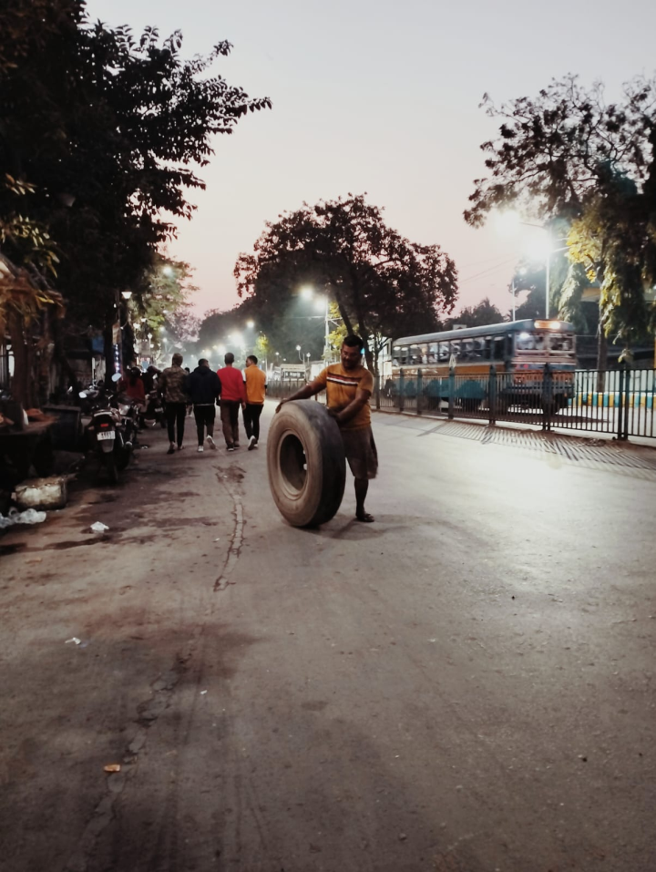
Zindagi ek safar hain suhana (3rd - Indrani Das Mahapatra)

