EVENT REPORT OF POST GRADUATE COURSE, DEPARTMENT OF
PHILOSOPHY, RKSMVV

WEBINAR/ SEMINAR
-2018-

Event: Seminar on ‘ETHICS AND EPISTEMOLOGY’ to observe WORLD PHILOSOPHY DAY
Organizer: Department of Philosophy
Date: November 29, 2018.
Resource Persons:
- Dr. Sanjukta Basu , Professor, Rabindra Bharati University
- Dr. Ranjana Mukherjee, Retd. Professor, Rabindra Bharati University
- Pravrajika Bhaswarprana, Principal, Ramakrishna Sarada Mission Vivekananda Vidyabhaban
No. of Participants: 100
Brief Description: On the eve of celebration of World Philosophy Day, the department of Philosophy of RKSMVV organized a one day Seminar to discuss epistemological issues and debates in philosophy as well as the importance of studying ethics and its relevance in present situation.
Programme Outcome: Apart from the excellent lectures delivered by esteemed speakers, the sessions were inter-active and several philosophical issues were critically discussed.
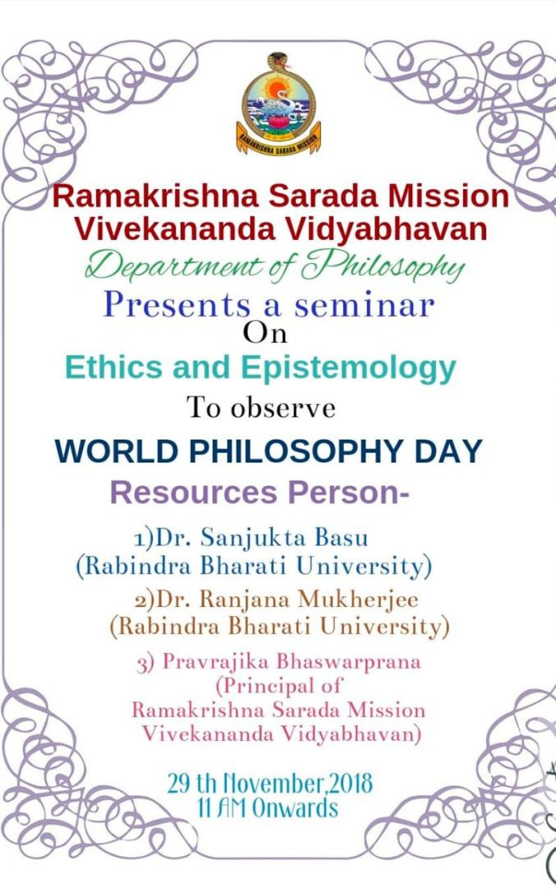

S

SEMINARS/WEBINARS 2019
Event: Higher Study Circle
Organizer:The Department of Philosophy, RKSMVV
Participants:Students, Research Scholars and Professors from different colleges & Universities (75)
Brief Description: The Department of Philosophy of RKSMVV has initiated a Higher Study Circle of teachers and research scholars in our college with the vision to enrich our knowledge in varied philosophical aspects.
The following lectures were arranged:
- Three consecutive lectures of Dr. Rama Chakraborty, Retd. Prof. Calcutta University, on ‘Philosophy of Mind’. Dates: 11.5.19, 18.5.19,25.5.19
- Lecture on ‘Environmental Ethics’ by Dr. Priyambada Sarkar, Prof. Calcutta University on 14.9.19
Programme Outcome: The Higher Study Circle initiative taken by the department of philosophy came out to be a big success as we all got the opportunity to listen to very enriched lectures of some renowned Professors.

Event: State Level Seminar on the eve of World Philosophy Day Celebration
Title : Philosophy - East and West
Date: 26.11.19
Venue: Muktiprana Sabhagriha
Participants: 50 (UG & PG Students)
Brief Description: A State Level seminar was organized by the department of Philosophy of RKSMVV on the eve of World Philosophy Day Celebration. In the first half of the seminar, the speakers were Pravrajika Bhaswaraprana, Professor Ranjana Mukherjee and Professor Ratna Datta Sharma. The second half witnessed the presentation of the Post Graduate students of the department of philosophy on various philosophical issues of East and West.
Programme Outcome: It was a very thought-provoking seminar as the first session of it had an inter-active session with the speakers. The post lunch session was also very interesting as the young Pst Graduate scholars of RKSMVV presented very well researched papers.

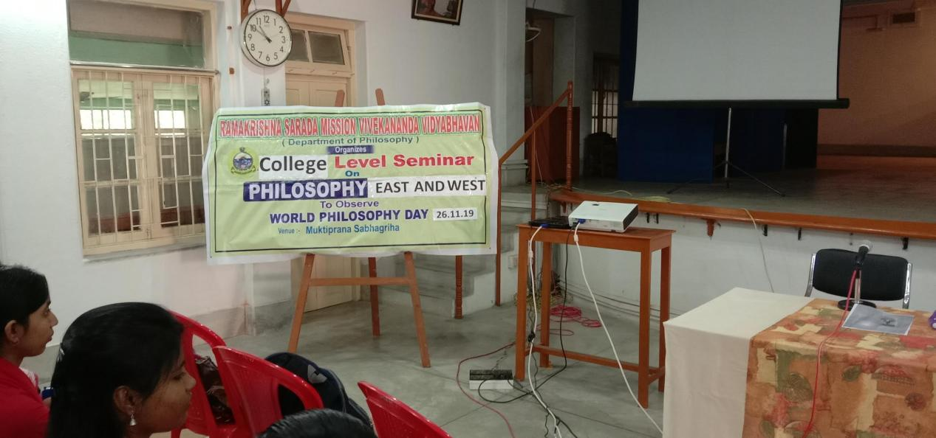

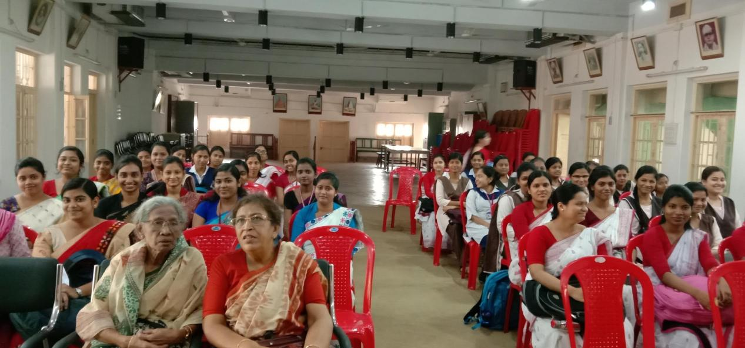

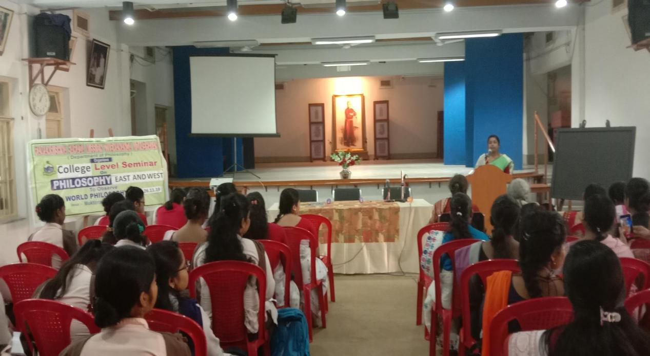

WORLD PHILOSOPHY DAY CELEBRATION 2019

SEMINARS /WEBINARS 2020

Event: HIGHER STUDY CIRCLE
Date: 25.1.2020
Topic: ‘Media Ethics’
Participants : PG Students
Speaker: Dr. Aparna Banerjee, Retd. Prof. Calcutta University
Brief Description: The Department of Philosophy of RKSMVV has initiated a Higher Study Circle of teachers and research scholars in our college with the vision to enrich our knowledge in varied philosophical aspects.
Programme Outcome: Professor Banerjee delivered a very well researched lecture on Media Ethics. Students teachers and research scholars from various institutions attended the Study Circle.

Event: National Webinar on YOGA: IN THEORY AND IN PRACTICE
Organizer: Department of Philosophy, RKSMVV
Sponsored by: ICPR
Date: 5th July, 2020.
Venue: zoom platform
Participants: Both UG and PG Students of Philosophy
Resource Persons:
- Dr. Ranjana Mukherjee, Retd. Professor, Rabindra Bharati University
- Pravrajika Divyanandaprana, Editor of ‘Samvit’, Sri Sarada Math, New Delhi
- Sm. Anjana Acharya Banerjee, Retd. Yoga Instructor, Burdwan University
- Sri Malay Mukhopadhay, Asst.Prof.PG.G.I.P.E, Banipur, N24Pgs.
- Sm.Taniya Nag, Physical Instructor, Serampore College.
Brief Description: It was an online Webinar where the speakers talked about the importance of yoga in keeping a balance between mind and body. Apart from theoretical lectures there was physical demonstration also about different asanas that will keep our mind and body fit and stress free during the covid time,
Outcome: Yoga is not a religion it is a way of life. The mental trauma and physical helplessness that we all faced during the Covid-19 outbreak, was really stressful. The Webinar, “Yoga: Theory and in Practice” – was an appropriate attempt to rejuvenate our distressed mind and body.

Event: One-Day International Symposium on Medical Ethics
Organized by: Ex-students of Department of Philosophy.
Date: August 29, 2020.
Venue: Zoom meet
Number of Participants: UG , PG students of PHilosophy, Teachers from RKSMVV and Invited guests from otherdepartments and Colleges. (90)
Resource Persons:
Prof. Ratna Dutta Sharma, Jadavpur University, Kolkata
Dr. Dhiman Ganguly, Consultant Pulmonologist, Retd Prof. Vivekanana Institute of Medical Sciences, Kolkata, Ex-President, Indian Chest Society.
Dr Sambrita Mukherjee, Speciality Registrar, Dept of Anaesthetics and Critical care, Epsom and St Helier University Hospitals, NHS Trust, UK.
Brief Description: The Department of Philosophy organized a Webinar reflecting a very relevant medical issue during pandemic situation. The Webinar was attended by students and faculty members from other departments also. Dr Dhiman Ganguly, Dr, Sambrita Mukherjee, from the medical background and Dr. Ratna Datta Sharma from the department of Philosophy delivered very well structured lectures in their own field.
Outcome: During the covid situation everyone was suffering from the anxieties of the pandemic and they were having various questions regarding the coping strategies of the situation the suggestions and do’s and don’t’s from the physician’s side helped them to understand and face the situation in a more dynamic ways.

Event: An Inter-Disciplinary Seminar
Organized by: Department of Philosophy, Education and Sociology
Topic: ‘Research Methodology’
Date: 8.3.22,
Venue Muktiprana Sabhagriha.
Brief Description:
An Interdisciplinary Seminar was organized jointly by Departments of Education, Philosophy and Sociology, on ‘Research Methodology” for all the 5th Semester Students and Post Graduate students of Philosophy. Professor Maushumi Guha of Department of Philosophy, Jadavpur University and Professor Prarthita Biswas of Department of Education, Adamas University, were the distinguished speakers who delivered excellent speech on the basic facts about Research Methodology. Professor Guha introduced the topic by explain the need to have a very focused yet clear view about the Research topic and Professor Guha explained in details both the Qualitative and the Quantitative Methodology and their applications.

Outcome: It was a very insightful session as the students got few basic ideas regarding research methods. Dr Guha introduced the need for us to do research and how we will be able to identify the issues that we will choose as our research topic. Dr Prarthita Biswas discussed about the particularities that we need to remember and follow while doing any research. The entire session enriched the students about the basics of research methodology which was the main intention of the workshop.
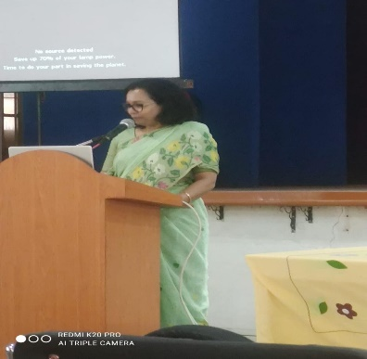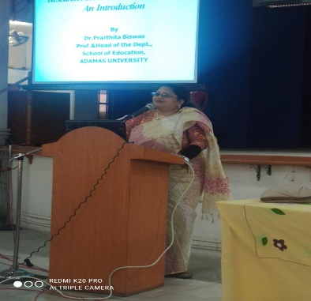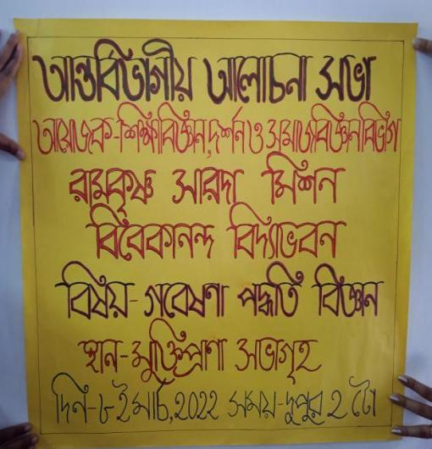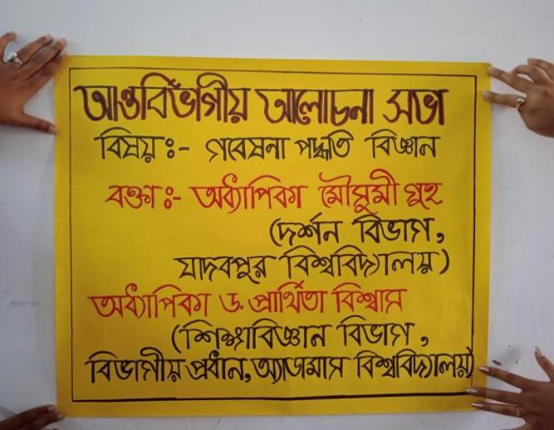

Event: An Inter-Disciplinary One- Day Workshop on ‘Research Methodology’
Organized by: Department of Philosophy, Education and Sanskrit
Date: 1.12.22.
Venue: Muktiprana Sabhagriha & Swamiji Bhavan
Speakers: Dr. Moushumi Guha,
Brief Description: An inter-disciplinary seminar was held on Research Methodology where students of all the semesters of Philosophy, Education and Sanskrit participated. Dr. Maushumi Guha, professor of Philosophy, Department of Philosophy, Jadavpur University, introduced the basics of Research Methodology. The speaker from the department of Education delivered lecture on the quantitative approach of research and Dr. of Department of Sanskrit gave elaborate demonstration on the referencing part of research.

Outcome: The one –day inter-disciplinary workshop benefited the student in understanding the basics of research methodology and this will help them in their future research oriented projects.

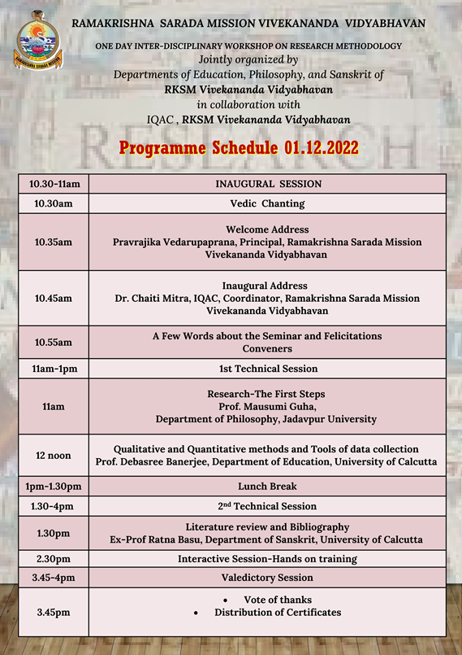

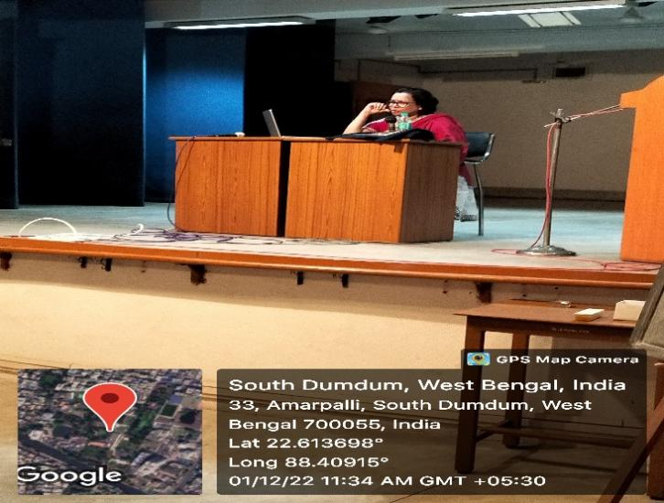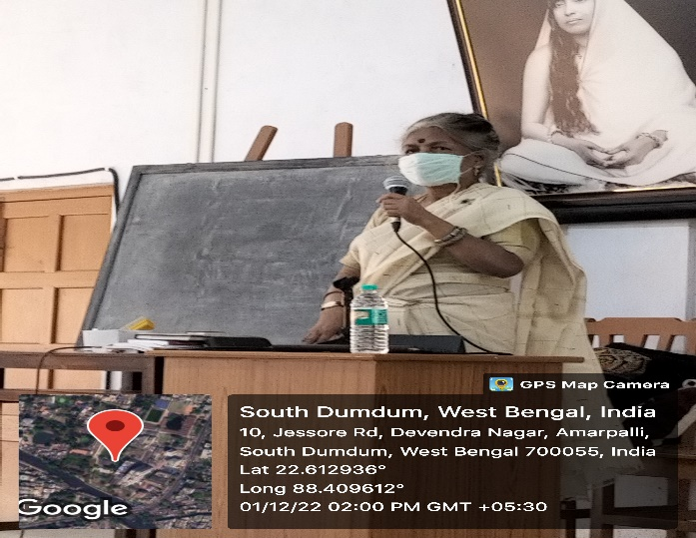
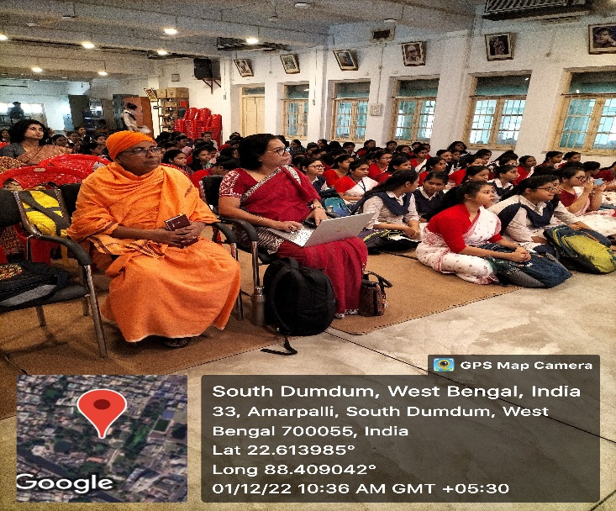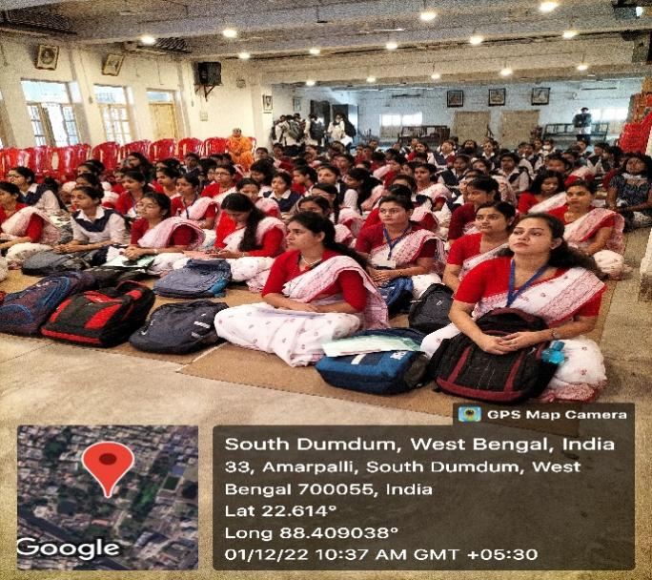

Event: Two Days’ International Seminar on ‘ROLE OF TECHNOLOGY IN THE NEW NORMAL: SOCIAL ETHICAL AND PSYCHOLOGICAL CHALLENGES’
Organizer: Department of Philosophy
Date: 25th &6th December 2022
Resource Persons:
Dr Nirmalya Narayan Chakraborty, Professor, department of philosophy, Rabindra Bharati University, as our key note speaker.
Dr. Sucheta Ghosh– ‘Humanity Towards Opulence Using AI ’
Dr. Shubhranil Som. – ‘Cyber Security: Role of User Behaviour, Social and Psychological Impact.
Paper Presentations by UG & PG Students
No. of Participants: 80
Brief Description : On the eve of celebration of World Philosophy Day, the Department of Philosophy of Ramakrishna Sarada Mission Vivekananda Vidyabhavan and Scottish Church College, jointly organized an International Seminar on - ‘ROLE OF TECHNOLOGY IN THE NEW NORMAL: SOCIAL ETHICAL AND PSYCHOLOGICAL CHALLENGES’. Apart from invited lecturers there was a parallel session of Professors and Research Scholars who shared their views regarding technology, AI and relevant issues. Apart from this a separate section was there for the students to voice their opinion in this issue. It was really a very enriched two days International Seminar which witnessed development of new perspectives regarding impact of technology in our lives.
Outcome: Apart from the excellent lectures delivered by esteemed speakers, the sessions were inter-active and several philosophical issues were critically discussed.

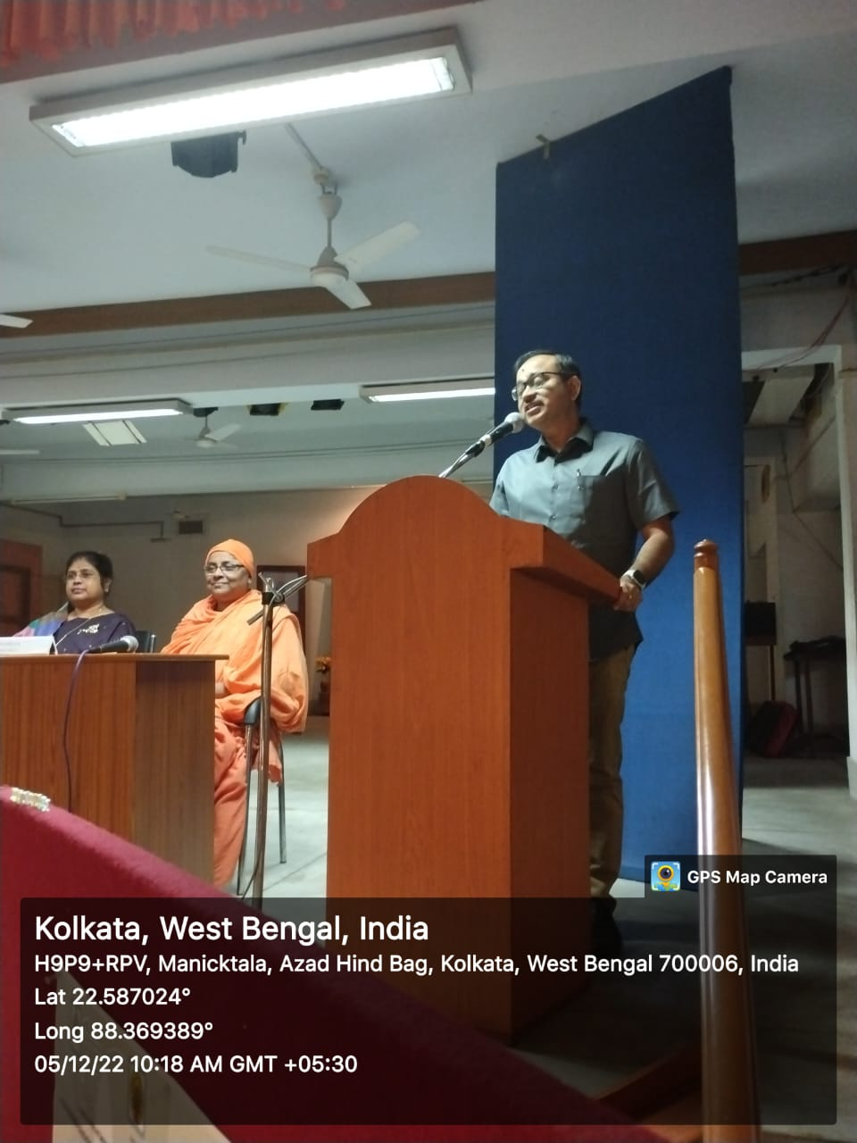
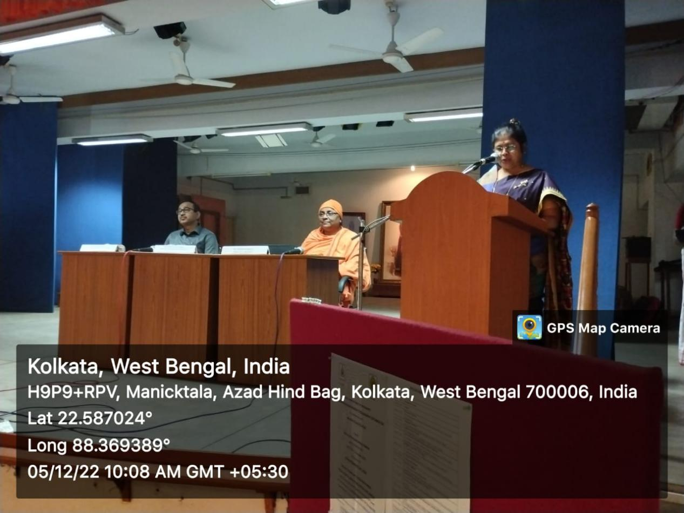
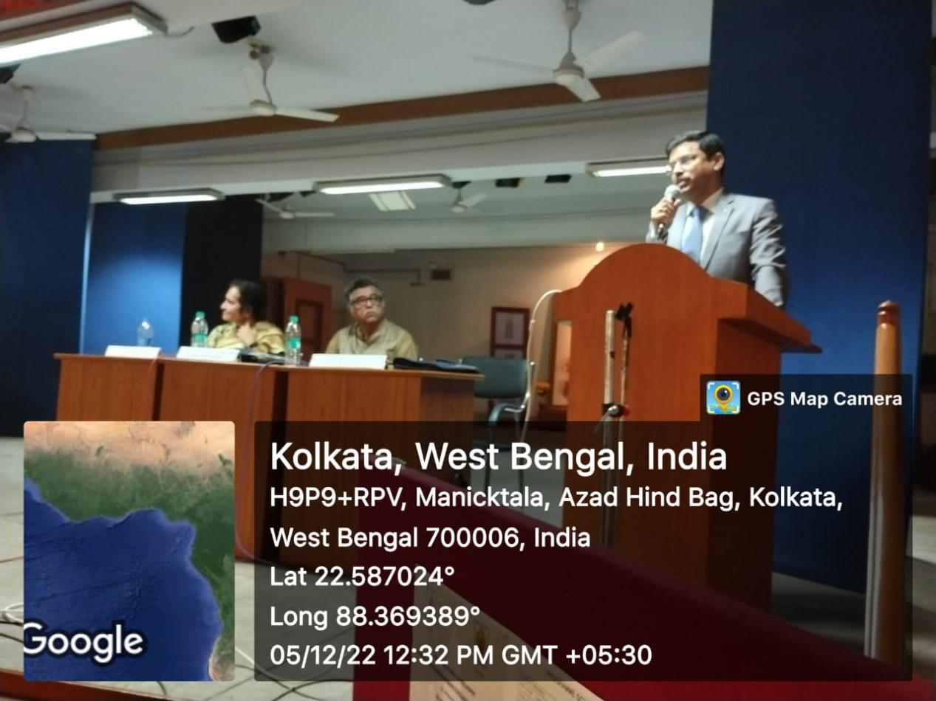
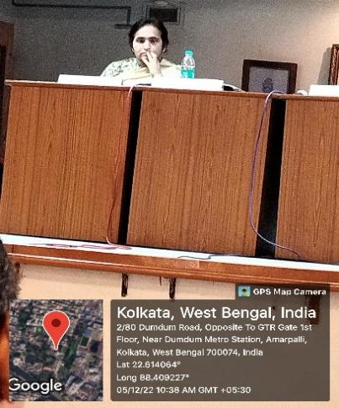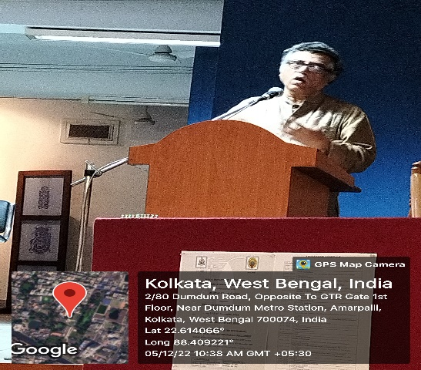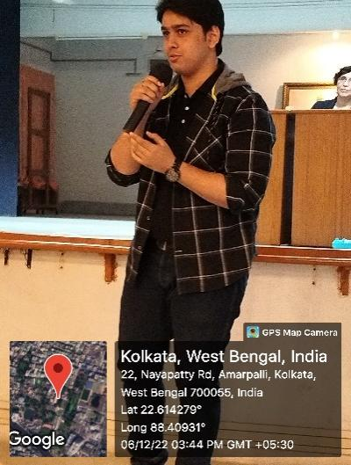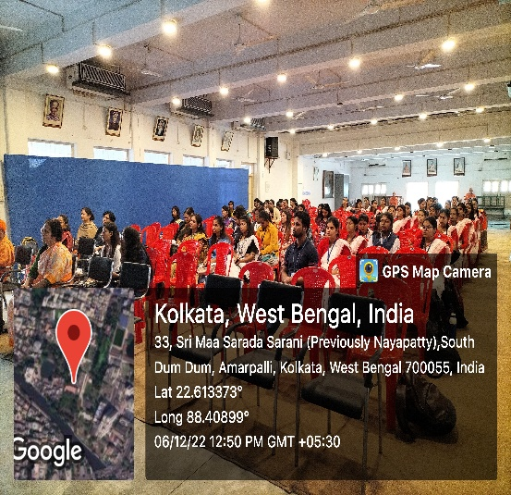
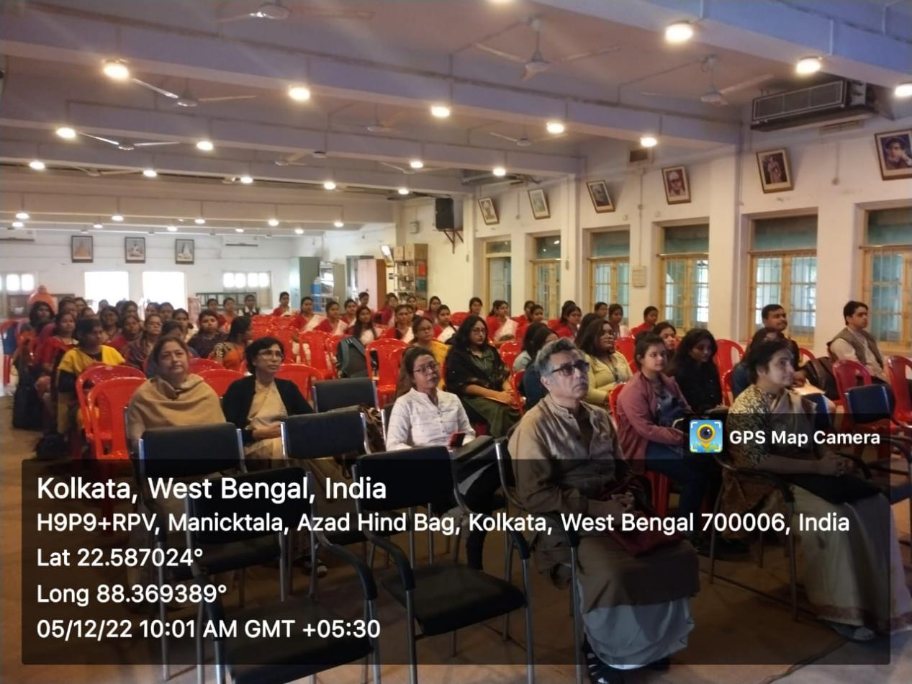
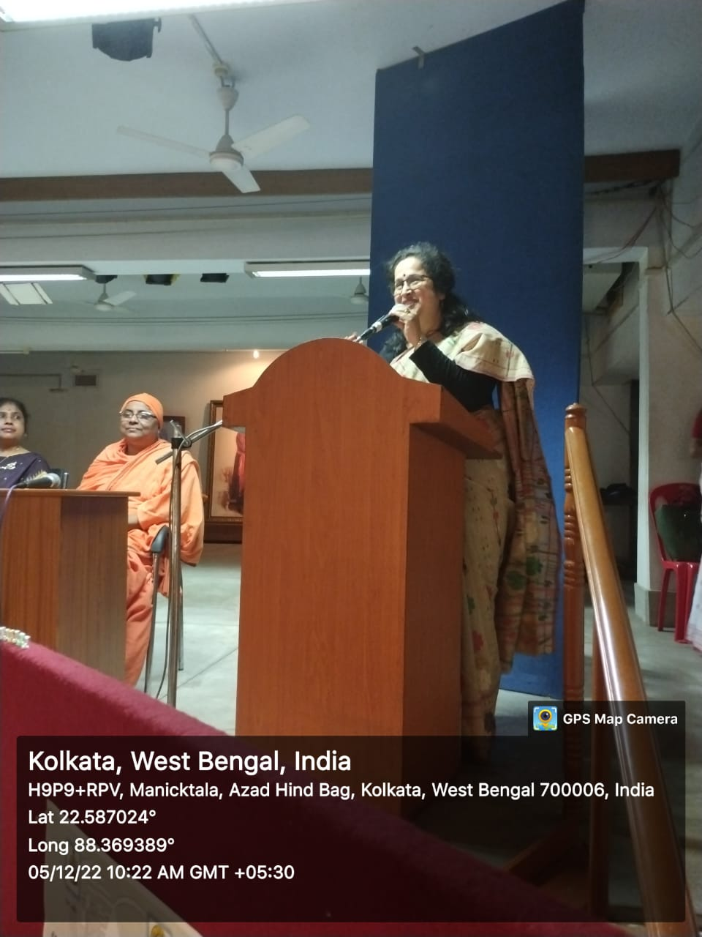
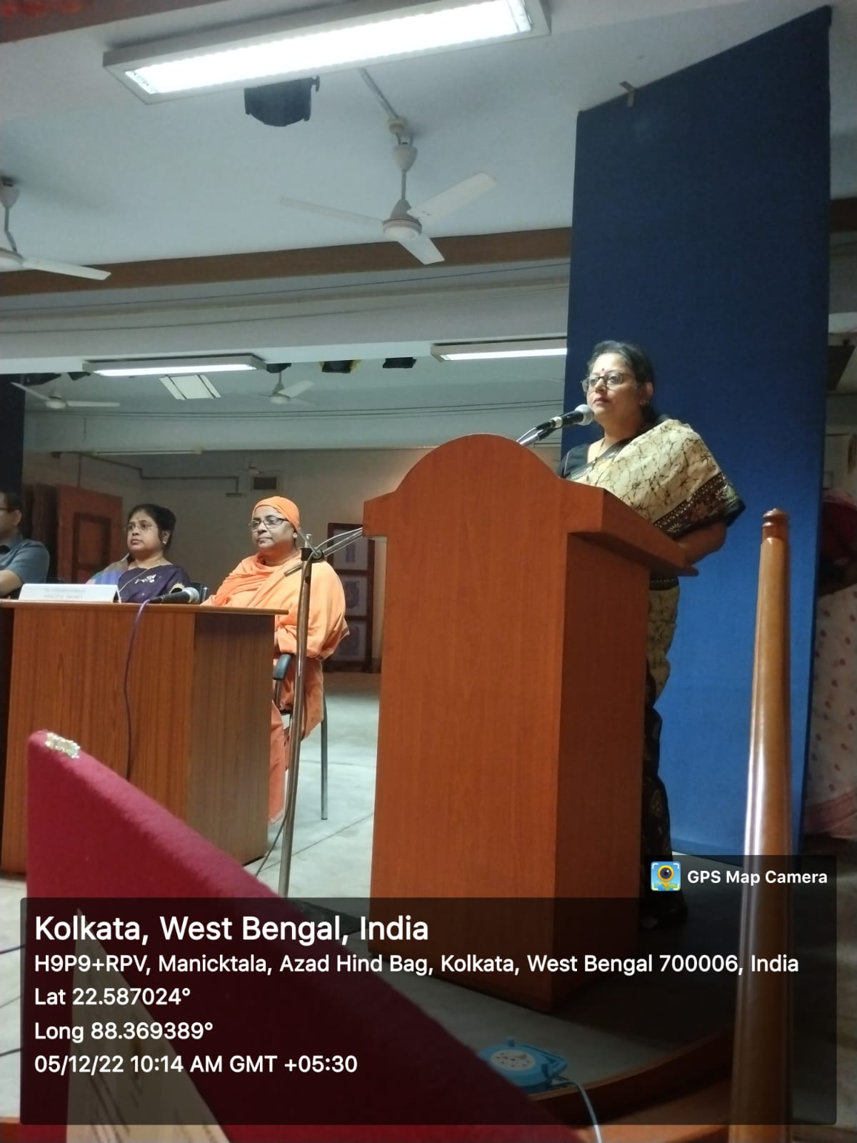

Seminars/Webinars 2023
Event: Seminar on World Philosophy Day
Name of the Topic – Revisiting Environmental issues From the Perspective of Indian Knowledge System
Date: 30.11.2023
Venue: Muktiprana SabhaGriha
Speaker:Dr. Priyambada sarkar and Dr. Sanghamitra Mukherjee
Number of Participants: 85 UG and PG Students
Brief Description:
TheDepartment of Philosophy organized World Philosophy Day in collaboration with Gurudas College, East Calcutta Girl’s College, Sammilani Mahavidyalaya, Shyampur Siddheshwari Mahavidyalaya, and Ananda Mohan College and under the patronage of IQAC of Ramakrishna Sarada Mission Vivekananda Vidyabhavan. The students of the collaborating colleges were given the opportunity to deliver small talk on various issues related to Indian Knowledge system. Esteemed speakers were also invited to share their views on the topic.
Programme outcome:
The presentation made jointly by the students of 5th Semester, which helped them experience the way to present a paper, use ICT, to face questions and to learn the benefits of group discussion. The other two semester students participated actively in the session.

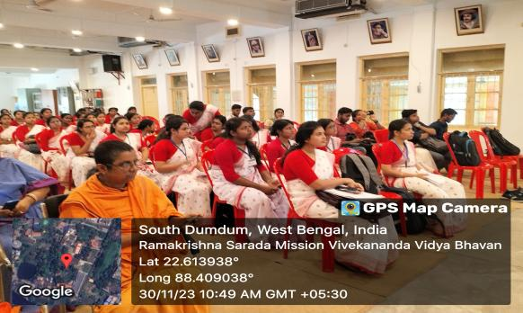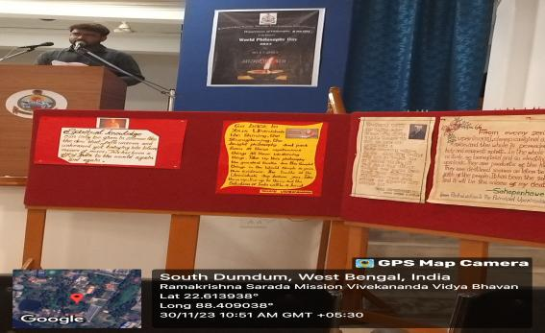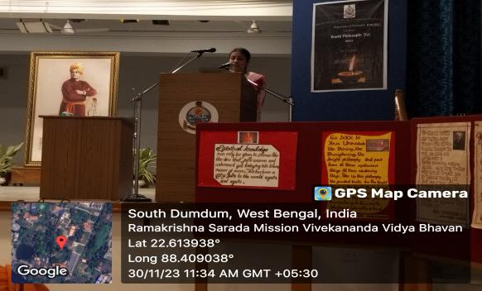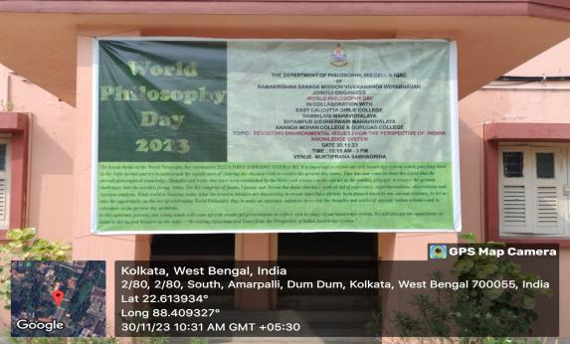
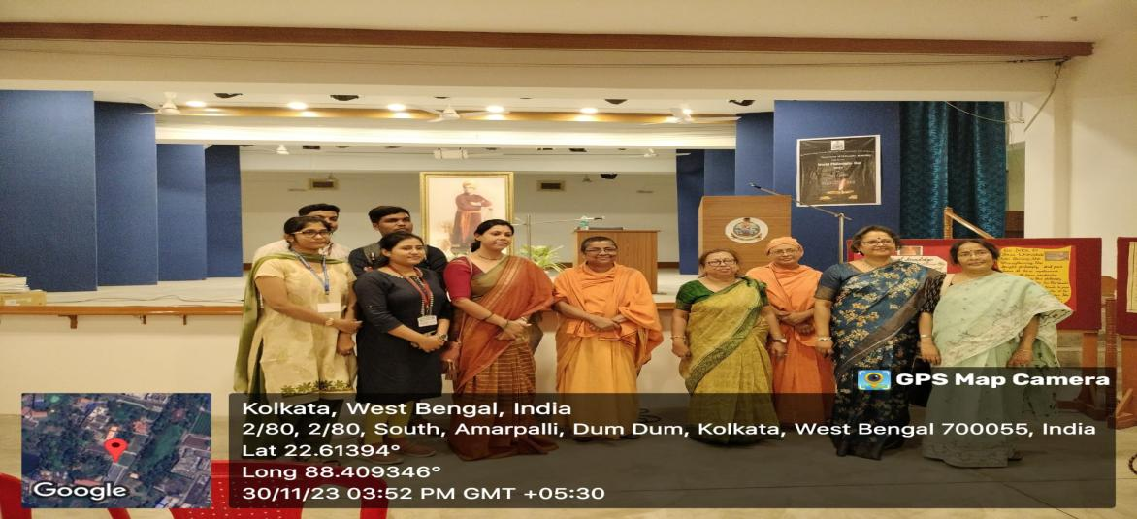
Event: Philosophy Post Graduate Degree Award Ceremony2024(Batches - 2018-2021)
Date: 23.4.24
Venue: Muktiprana Sabhagriha
Organized By: Deaprtment of Philosophy in collaboration with IQAC of RKSMVV.
Chief Guest: Prof. Basab Chaudhuri, Principal, Heritage Institute of Technology

Event: Philosophy Post Graduate Degree Award Ceremony
Date: 23.4. 2024
Organized By: Department of Philosophy in collaboration with IQAC of RKSMVV
Venue: Muktiprana Sabhagriha
Invited Guest: Prof. Basab Chaudhuri, Principal, Heritage Institute of Technology.
Description: The department of Philosophy organized the award ceremony of the Post Graduate students of Philosophy to give away the Master Degree Certificates to the students of batches 2018, 2019, 2020 and 2021. Professor Basab Chaudhuri was invited to grace the occasion. Our Principal Pr. Vedarupaprana gave the keynote address, followed by the briefing of the journey of the department of philosophy to materialize the opening of the PG Autonomous Course under the affiliation of WBSU in 2016, by IQAC member Dr. Bidisha Chatterjee who is also one of the faculties of the department. Prof. Chaudhuri gave away the certificates after delivering his brief but inspirational talk to the students. the highest scorer of each batch were awarded with special prizes also. The session ended with the words of experience of the students who got the MA degree from the institution and vote of thanks given by faculty member, pr. Ishtatmaprana.
Outcome: The students were overwhelmed by being a part of the ceremony and expressed their gratitude to the college and the faculty members to help them build up a bright future.

