NSS UNIT, RKSMVV
Activities of 2021
1.Community Service on 26th January,2021
NSS unit has organized a short cultural programme on 26.01.2021. Four NSS volunteers and twenty local children participated in it. After the programme gets over pens, pencils, copies, masks, and food packets were distributed among the children.
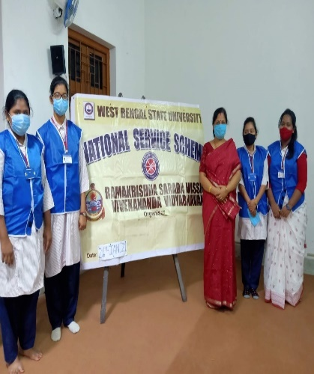
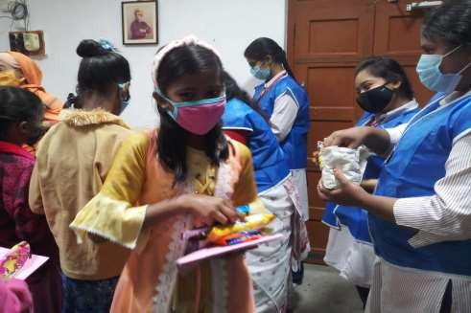
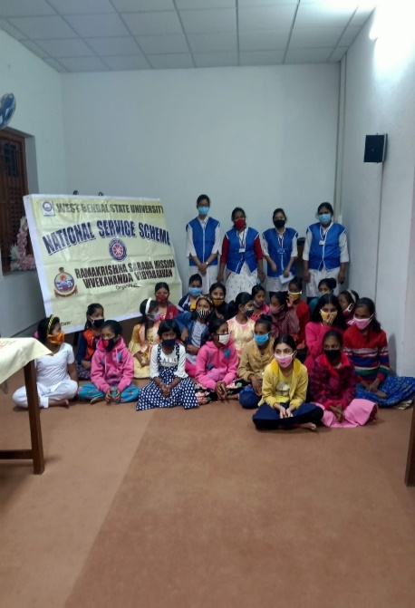
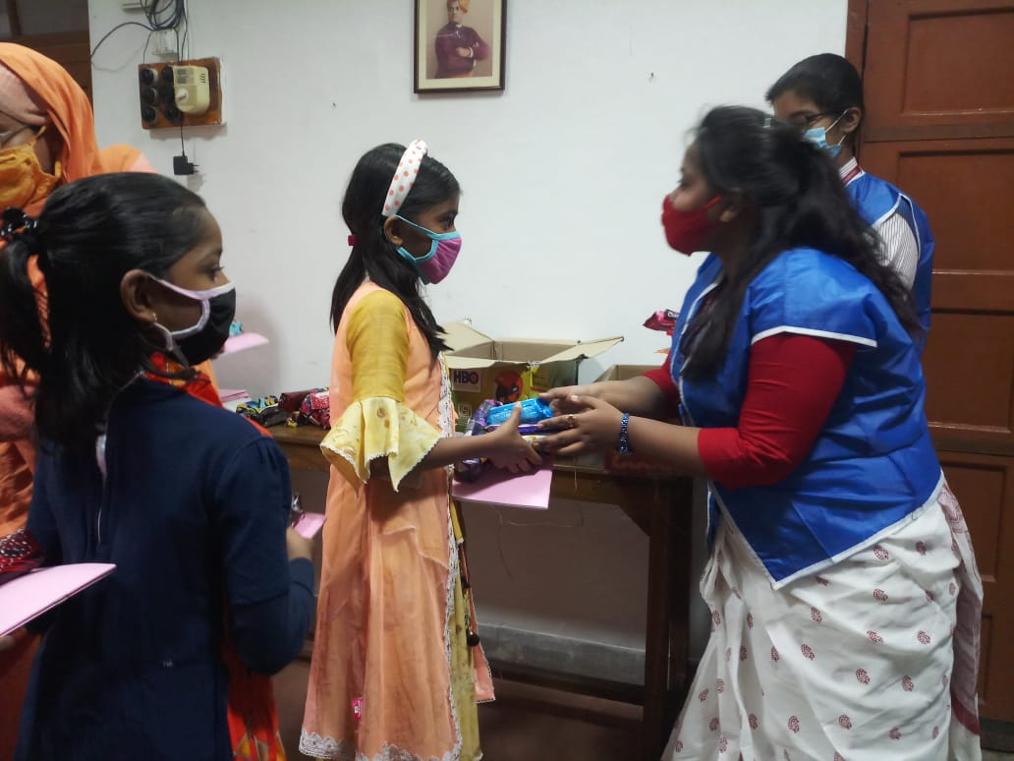
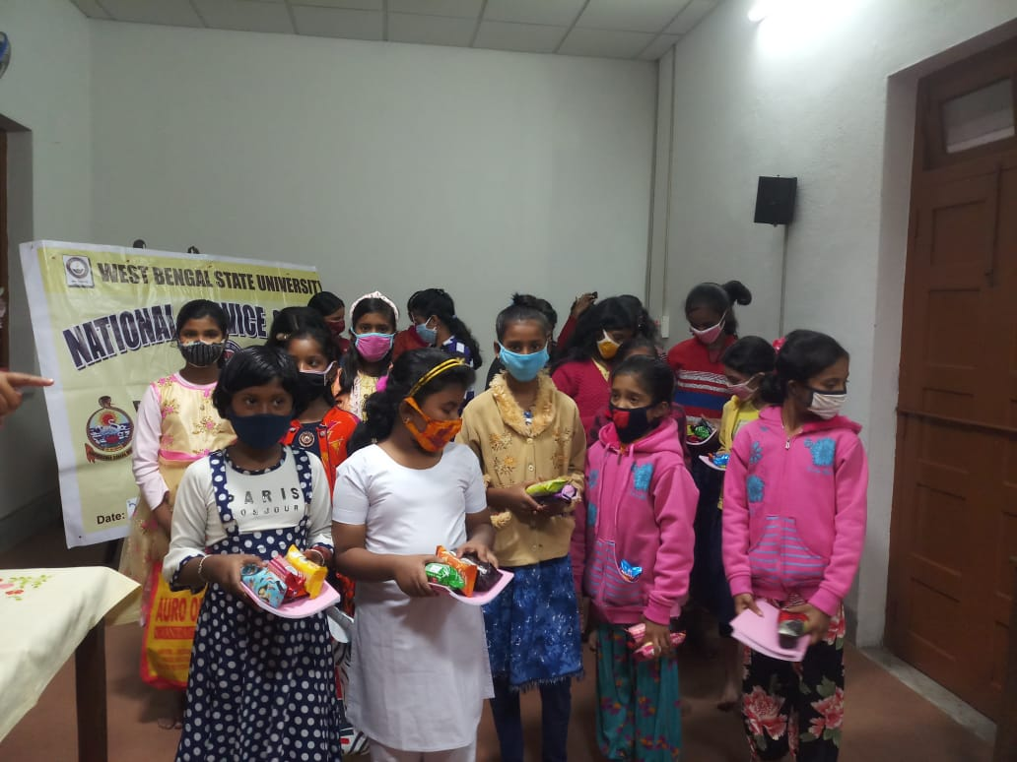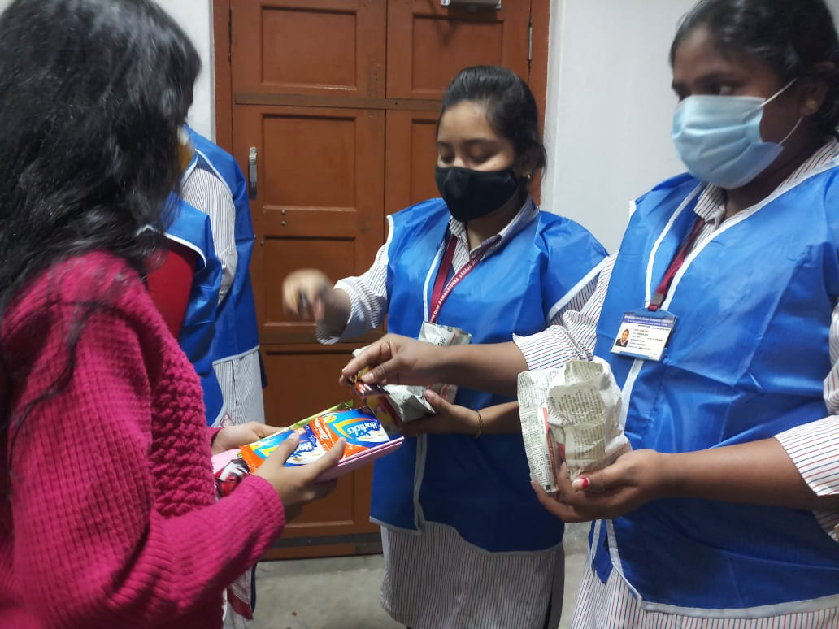
2.Workshop on Clean Campus
NSS PO Dr. Sanghamitra Mukherjee has participated in One Day Workshop on Clean Campus Development & Waste Management Under SAP organized by West Bengal State University, NSS Cell in association with HMM College for Women,Kolkata on 27th January,2021

3.West Bengal State University Foundation Day
Two NSS volunteers participated in the programme held on 26.02.2021 to celebrate the University Foundation Day at West Bengal State University.
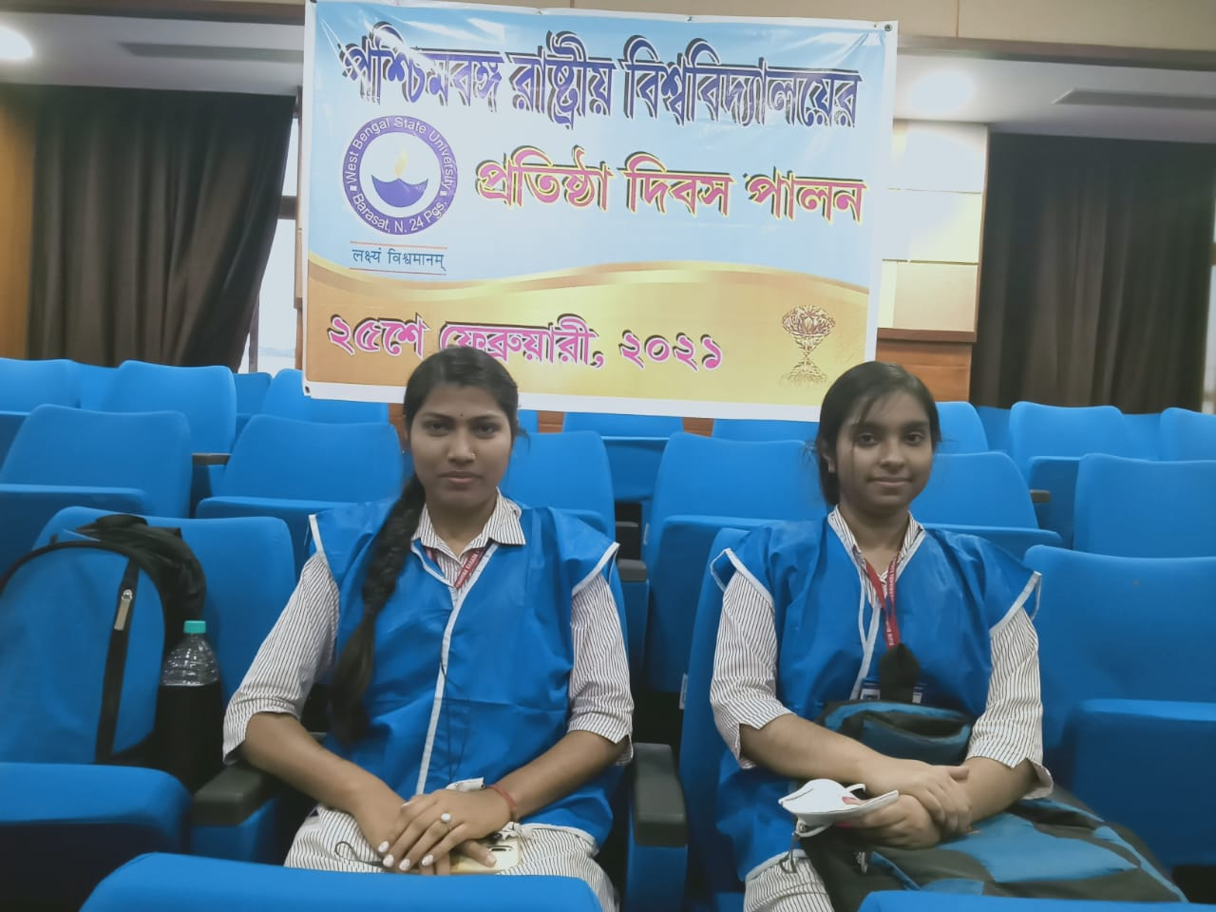
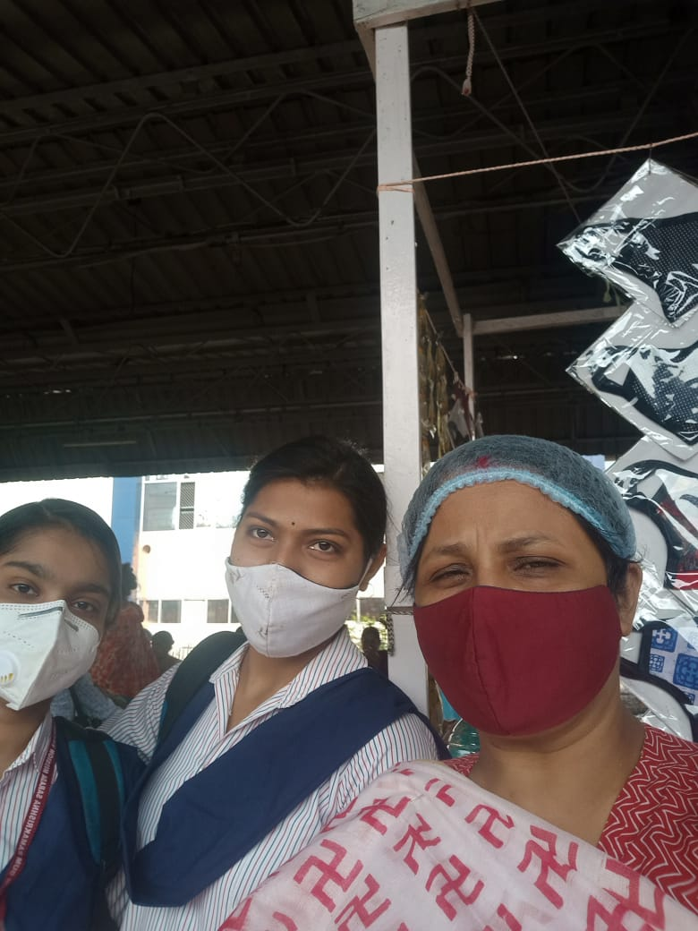

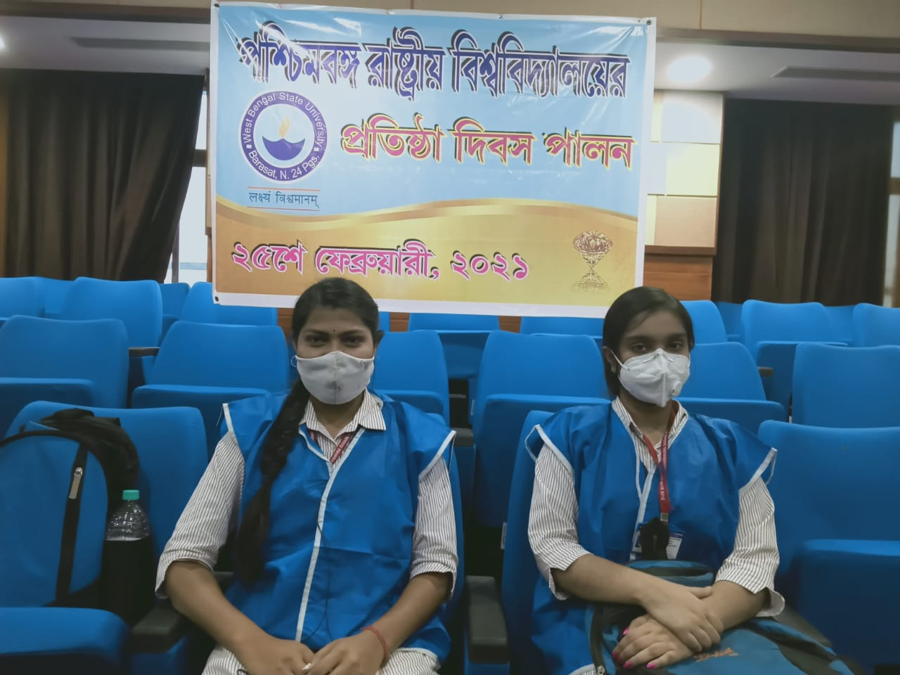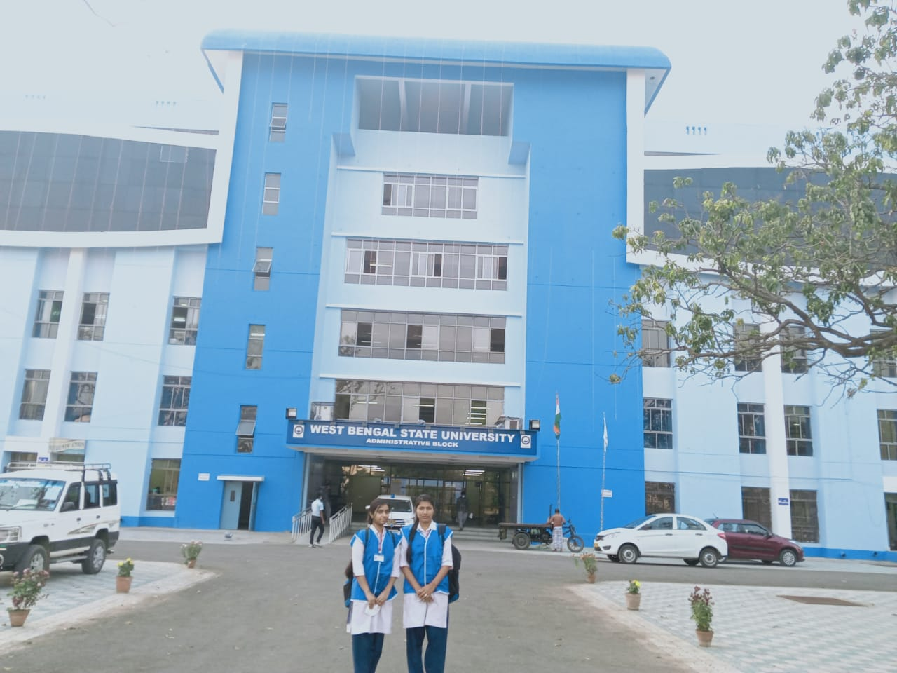

World Environment Day
To mark the celebration of World Environment Day, NSS Unit conducted a one-day e-workshop on the ‘Swachhta Action Plan ' on 5.6.2021. The agenda of the workshop was to create awareness of the Swachh Campus Manual. More than 30 volunteers attended the workshop. The participants were addressed by NSS PO Dr. Sanghamitra Mukherjee. The contents of the Swachh Campus Manuals was explained in detail by the speaker. A short video was made on Ecosystem Restoration, the theme of World Environment Day2021
You Tube Link: https://youtu.be/K85XN8q2Nrg?si=ez-G0fQ63LBtaxwt
International Yoga Day 2021
International Yoga Day was virtually observed by the NSS Unit, RKSMVV on June 21st, 2021. It provides an excellent opportunity for college students to engage in yoga practices from the comfort of their homes. This day emphasizes the physical, mental, and spiritual benefits of yoga, encouraging students to integrate these practices into their daily routines. During the pandemic, the observance of International Yoga Day at home by college students became particularly significant. With lockdowns and social distancing measures in place, traditional group activities and in-person classes were not feasible, making home-based yoga practices essential for maintaining physical and mental health.NSS volunteers were instructed to practise yoga at home. Two videos were made by the students to illustrate several yogasanas.
Outcome:Practicing yoga at home during the pandemic helped students cope with the stress and uncertainty of the times. It provided a structured routine, physical exercise, and mental relaxation, which were crucial for managing anxiety, maintaining fitness, and fostering a sense of normalcy. The flexibility to practice yoga at any time also made it easier for students to integrate yoga into their daily schedules, enhancing their overall well-being during a challenging period.
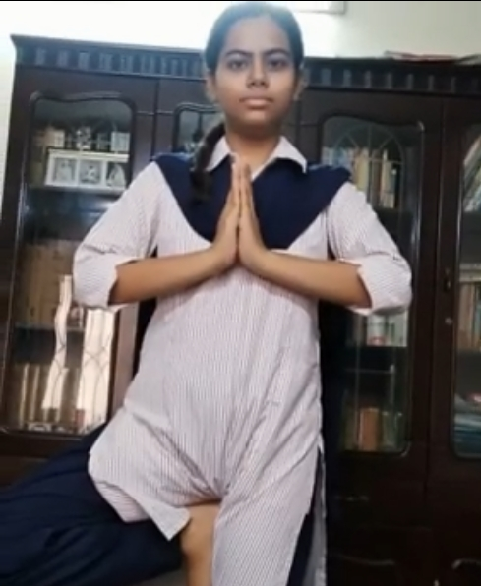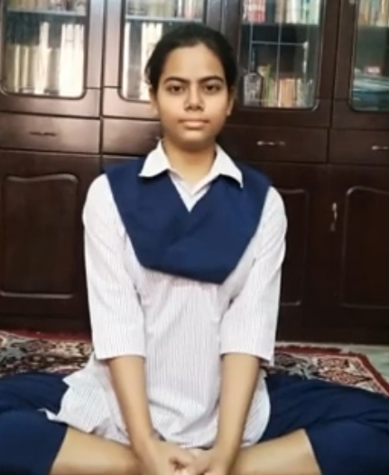
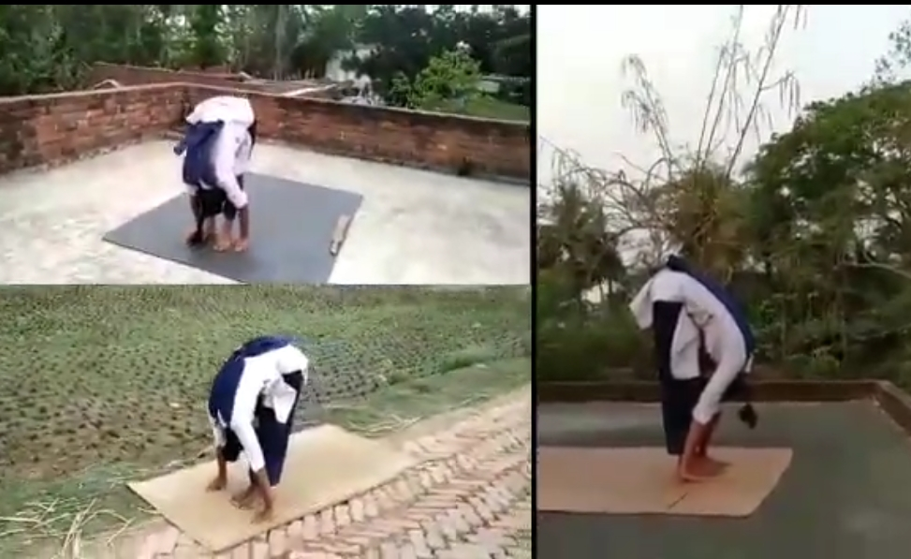
You Tube link https://youtu.be/uZ1iL6rMOdE?si=fgBzcYX1JXB4U0HH
NSS Day Celebration
- A short cultural programme was arranged online on 24th September,2021 to celebrate the NSS day. A video was made on the several activities of the NSS Unit of our college.
You Tube Link: https://youtu.be/UDWZhZ-R60o?si=i2ipN_gTf2zMu8t-
Covid Vaccination
- A Covid vaccination camp was successfully held in our college campus by the NSS unit in collaboration with the Higher Education Department Govt. of West Bengal, with a significant turnout of students, staff, and teachers receiving the vaccine on 7th October,2021. Additionally, members of the local community availed themselves of the opportunity, resulting in a total of 120 individuals being vaccinated. The active involvement of twelve NSS volunteers was instrumental in ensuring the smooth execution of the camp.
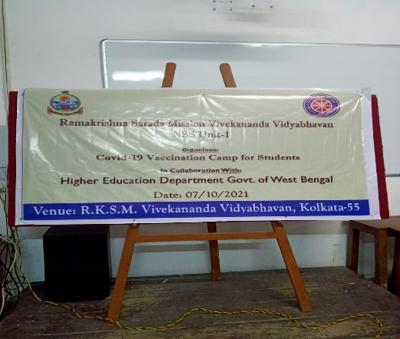

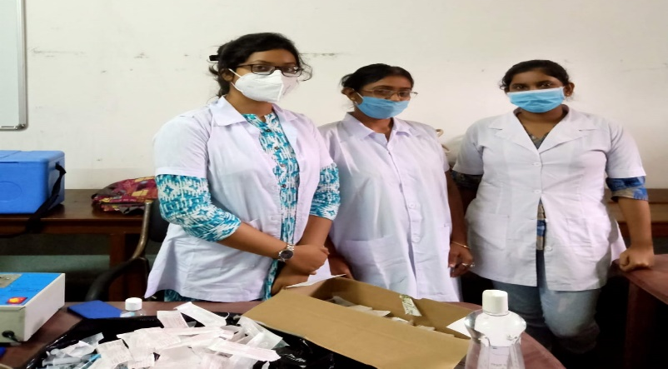

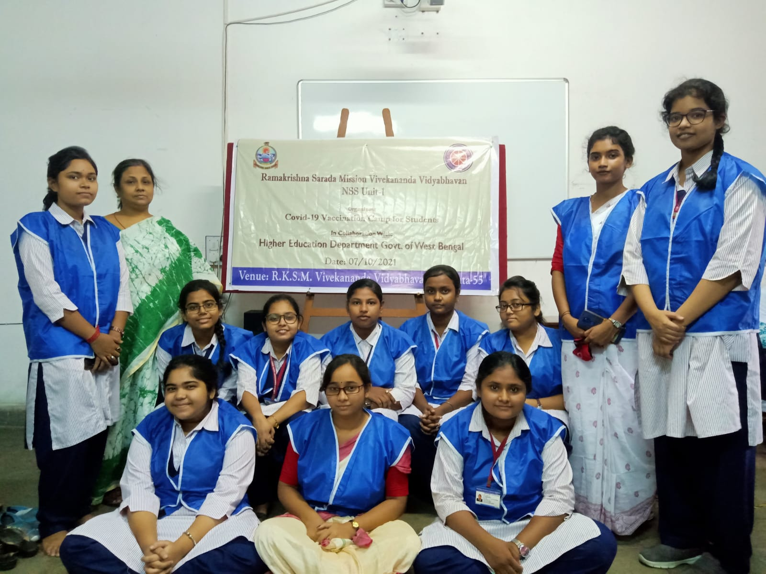
New India @75 Phase-2
The NSS unit of our college has participated in New India @75 Phase-2 in October 2021.WBSAP & CS observed a campaign in the name & style of New India@75 which was being planned to observe across the 25 schools and 25 colleges in West Bengal in two phases(Phase l&ll) engaging the adolescents and youth to do the awareness campaign on HIV, Tuberculosis and Blood Donation Awareness Programme. The program was launched by NACO. Our NSS volunteers participated in the campaign and they made several posters and short videos on the three issues. Videos were made on Azadi ka Amrit Mahotsav also. Medha Kundu, Semester-3, Department of History was the Brand Ambassador of our college in the New India@75 Phase-ll programme.
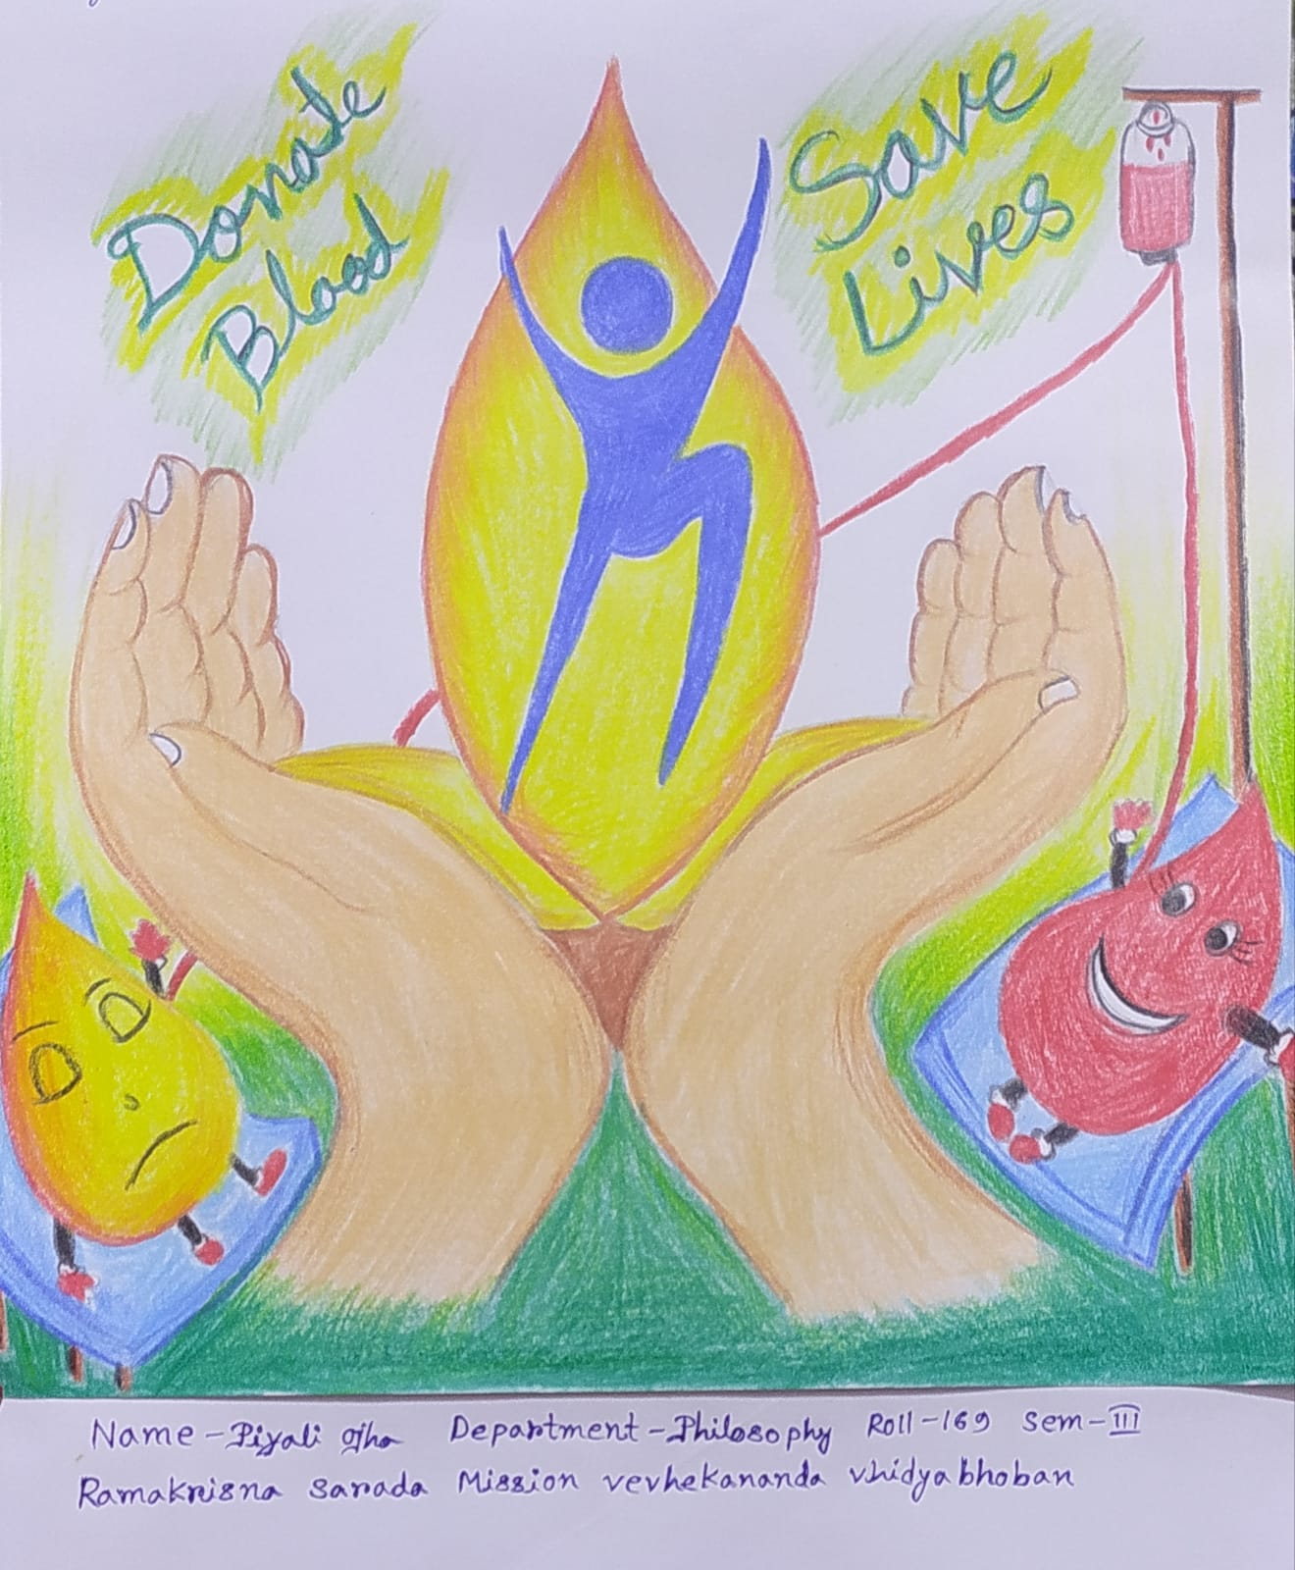

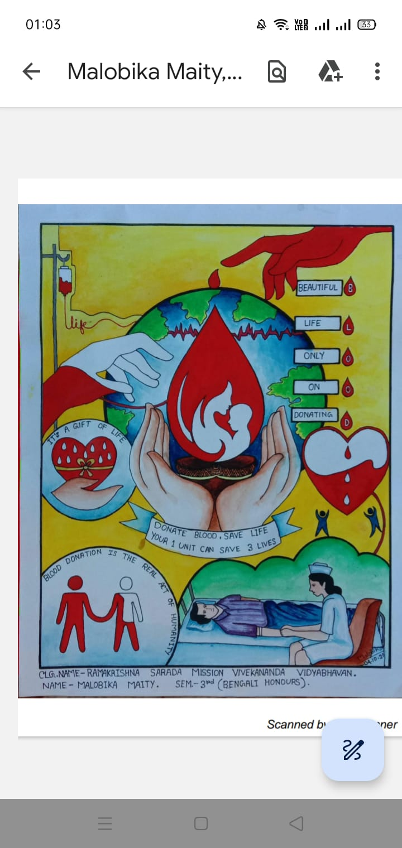
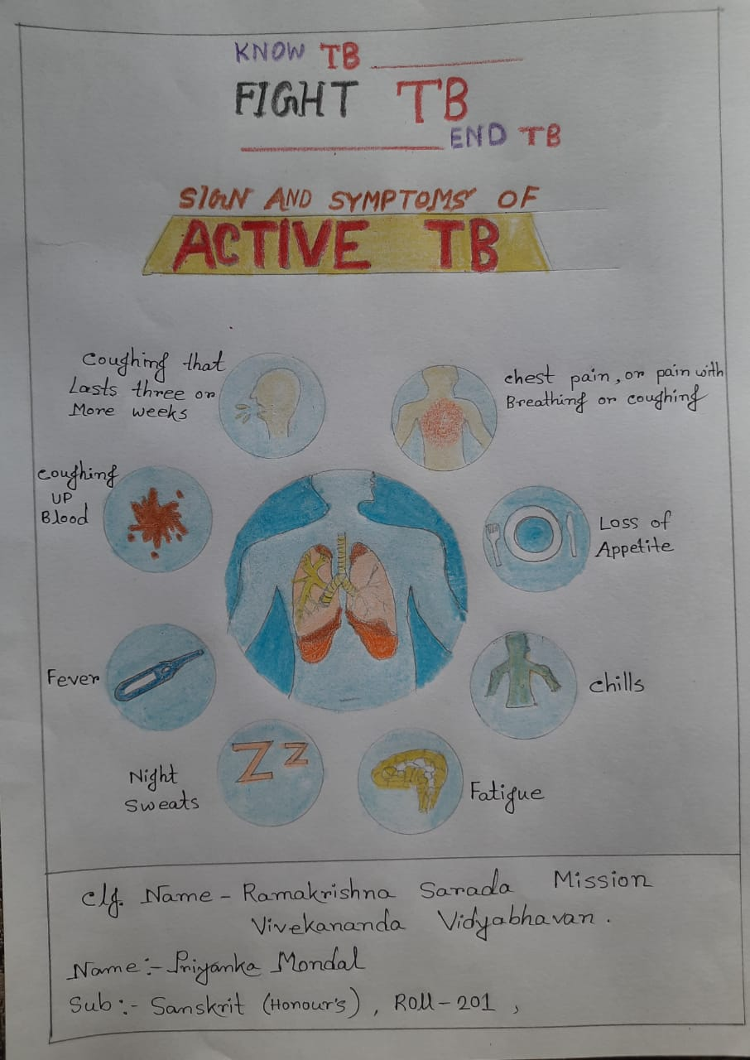
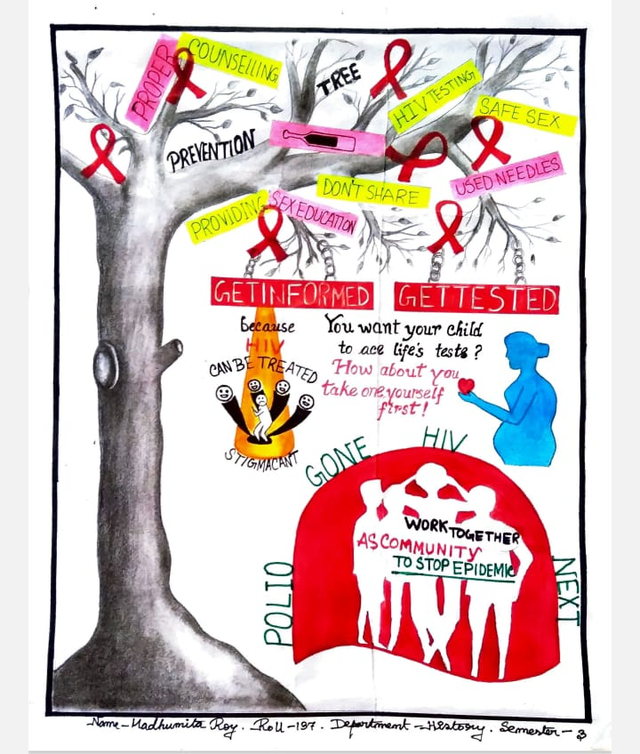
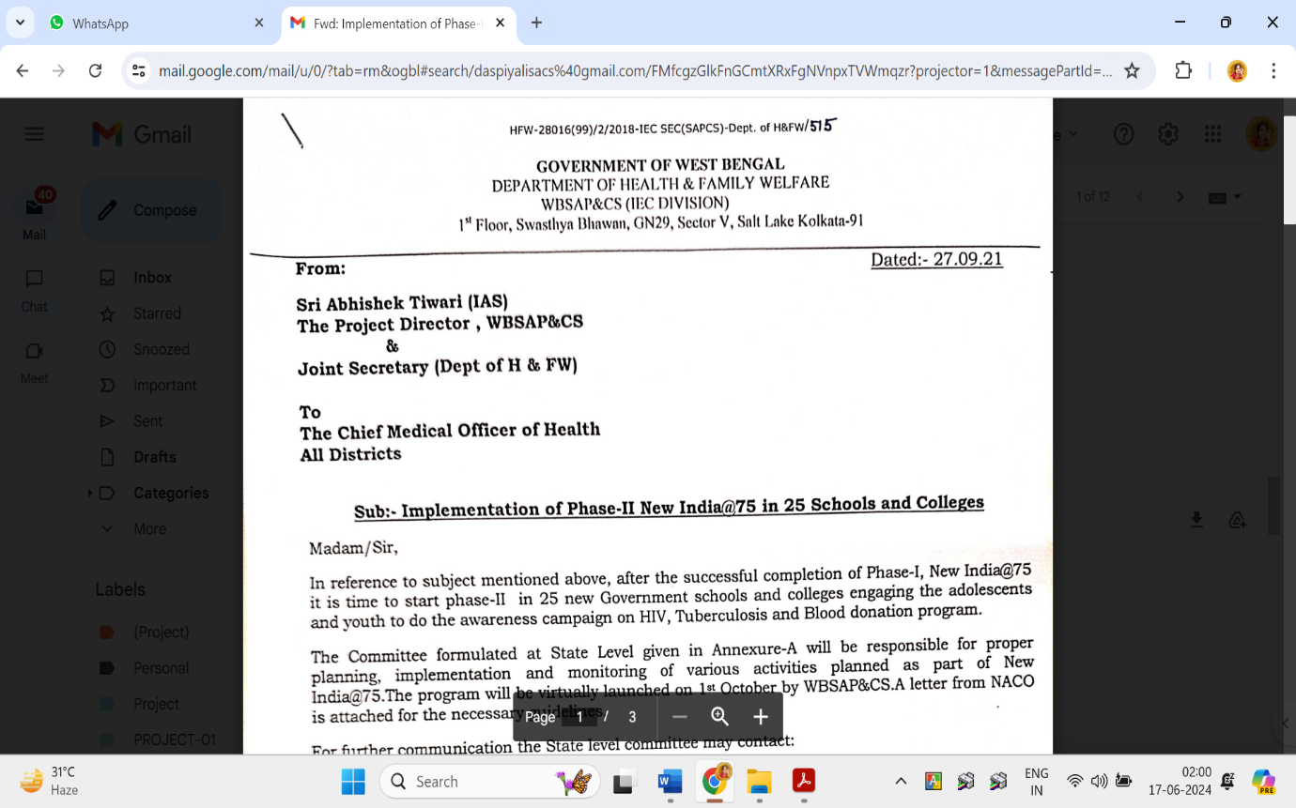
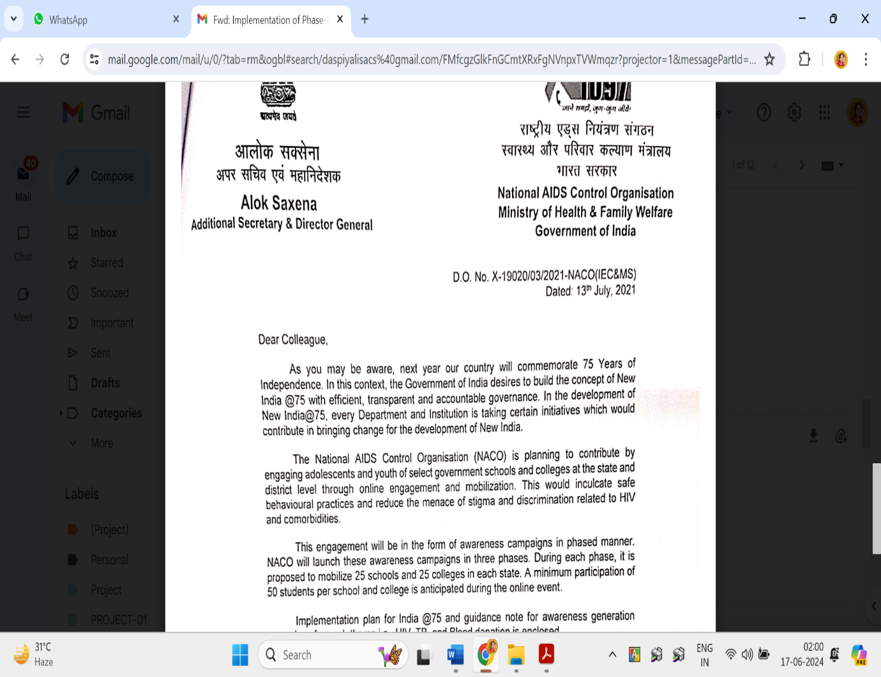
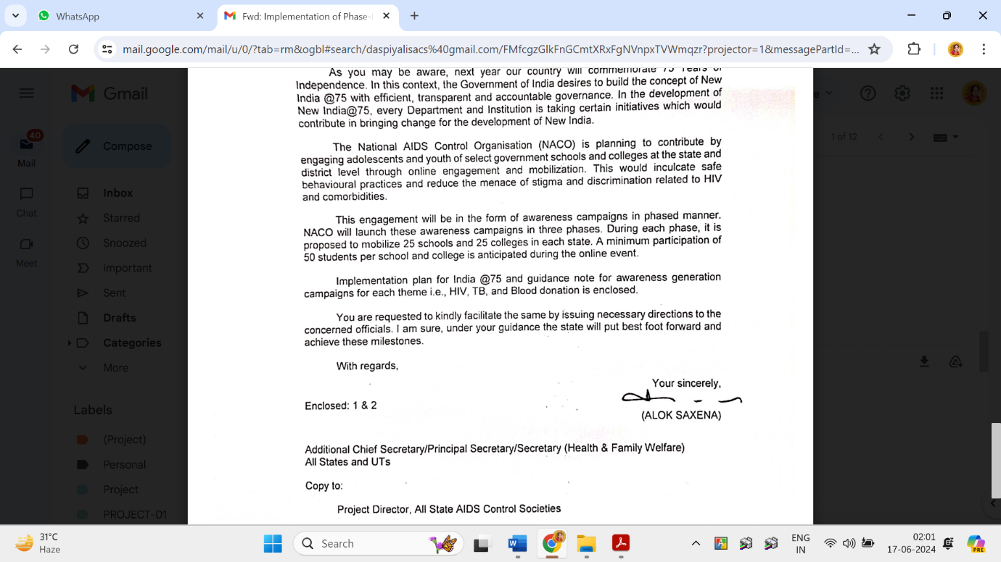

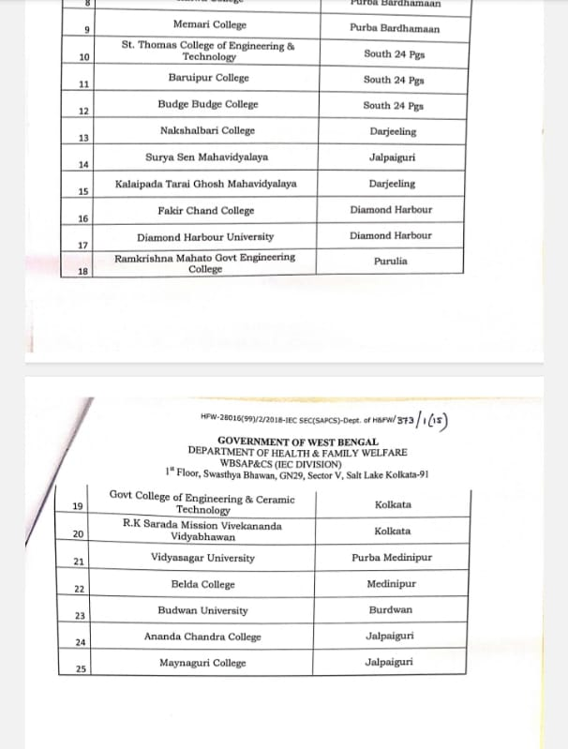

Red Road Parade
Two of our NSS volunteers have participated in the selection of volunteers for the Republic Day Parade on 23.12.21, though they were not selected at final.
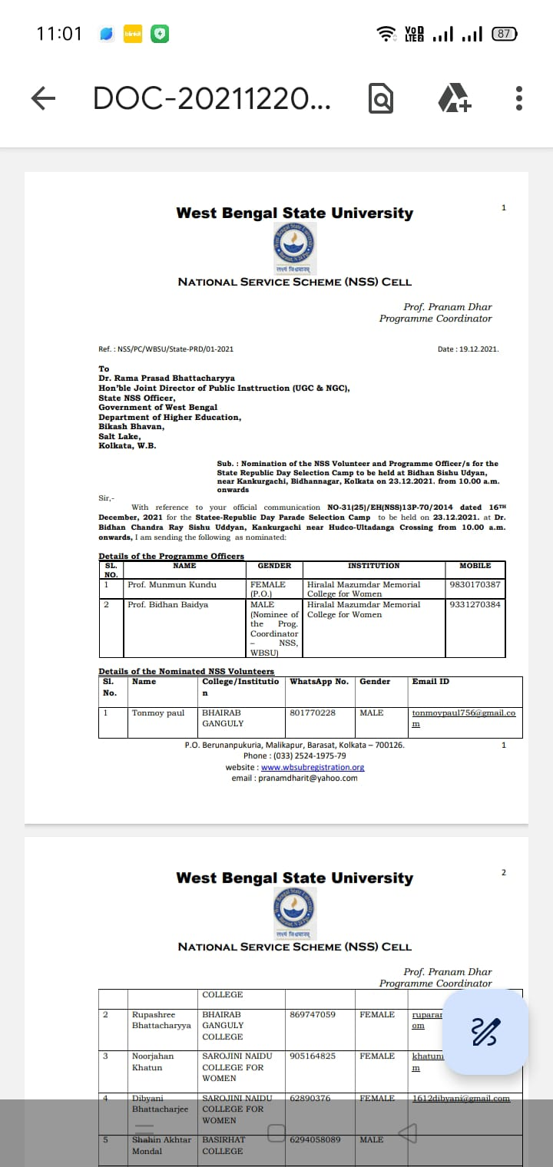
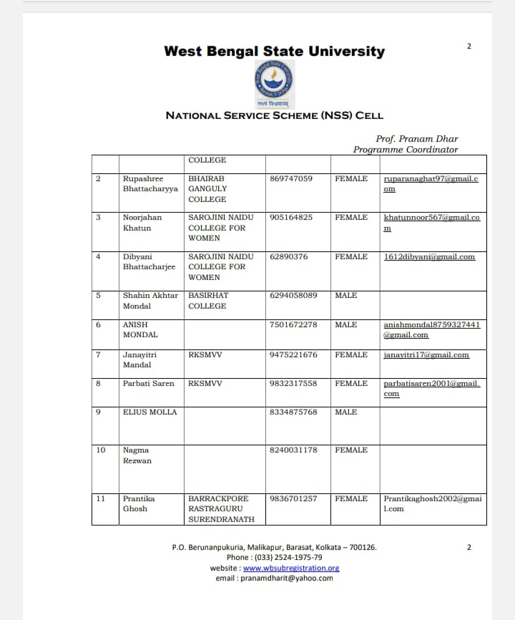

World Aids Day
The National Service Scheme (NSS) volunteers organized a significant event commemorating World AIDS Day. The event aimed to raise awareness about AIDS and its prevention strategies among the community members. The event commenced with an inaugural address by our Principal Pravrajika Vedarupaprana, emphasizing the importance of understanding HIV/AIDS and combating stigma associated with it. This was followed by informative sessions conducted by NSS PO Dr. Sanghamitra Mukherjee, who shed light on the prevention of HIV/AIDS. Some volunteers presented paper on transmission, symptoms and treatment of AIDS. treatment, The event concluded with a pledge-taking ceremony, where participants vowed to spread awareness and support individuals affected by HIV/AIDS. Overall, the World AIDS Day event organized by NSS volunteers proved to be an enlightening and impactful initiative in the ongoing fight against HIV/AIDS.
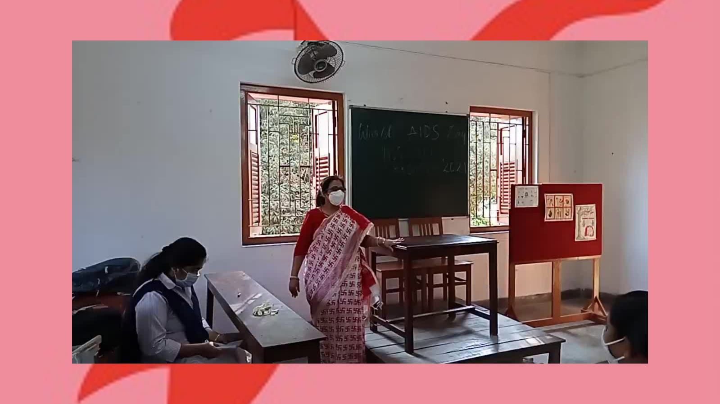
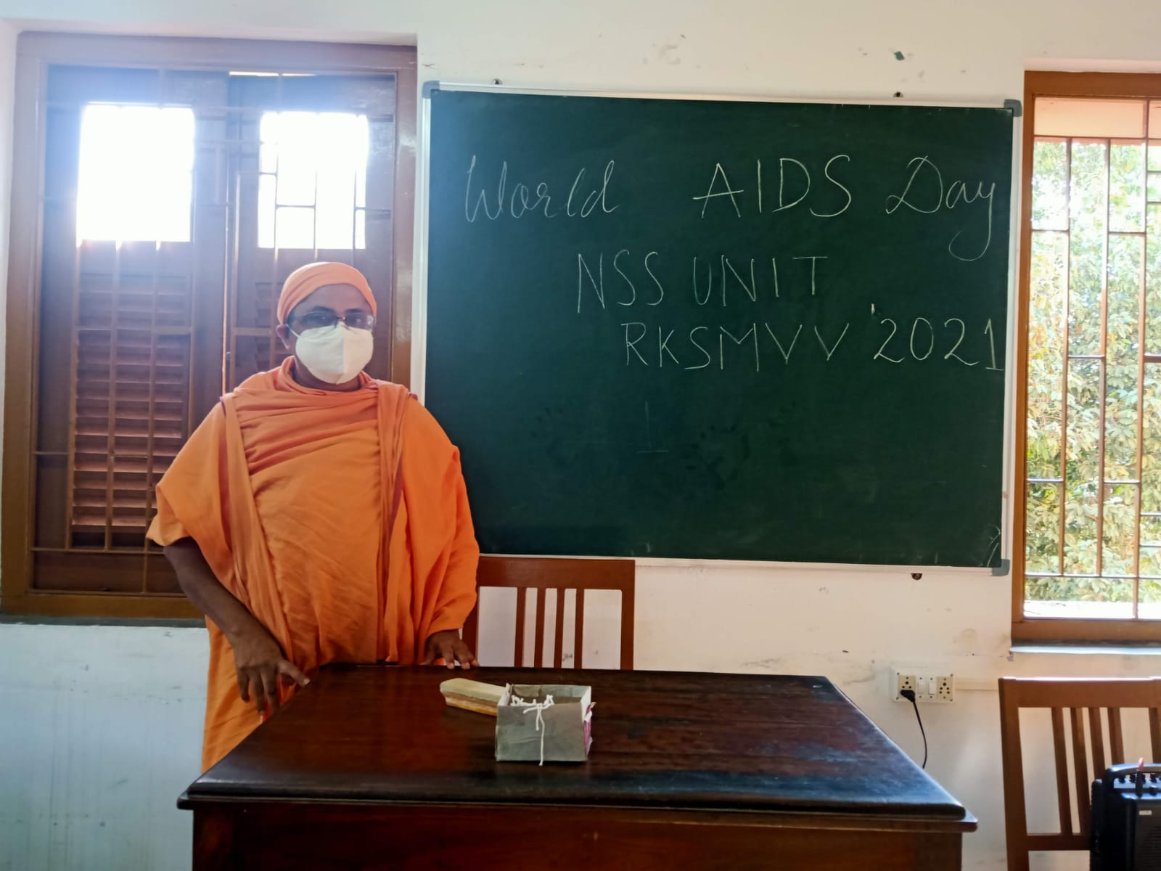
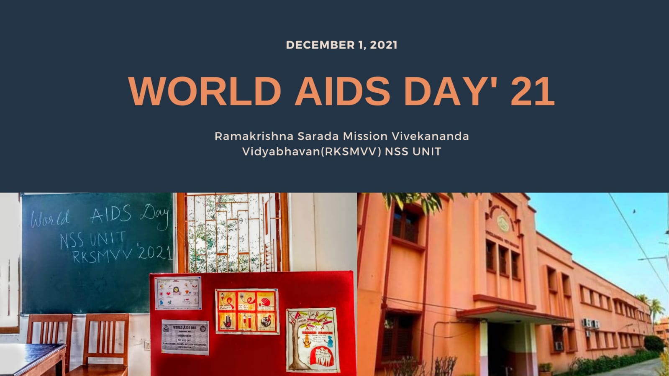
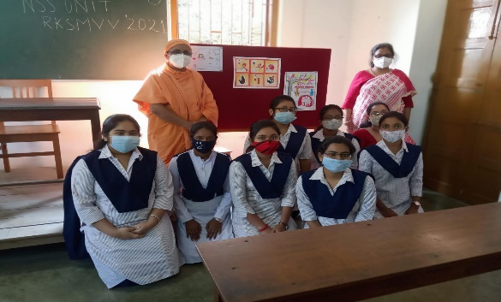
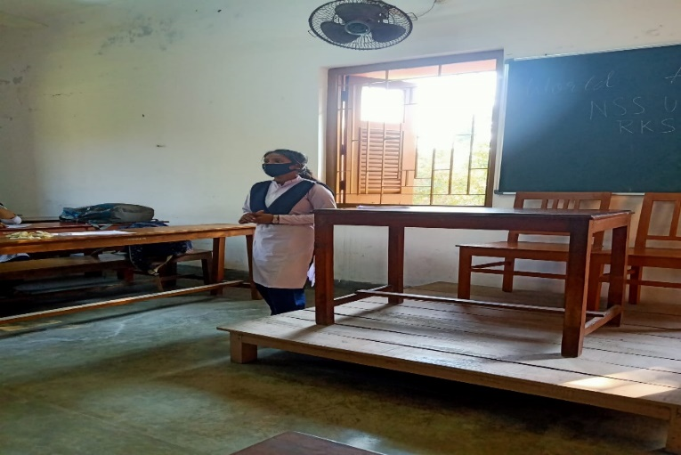
You Tube Link: https://youtu.be/43TErJ5zEHk?si=DEdVaqNOGDvj_xES
Essay Writing by NSS volunteers as part of 25th National Youth Festival
Our 30 NSS Volunteers participated in the Essay Writing Competition as a part of National Youth Festival organized by Department of Youth Affairs, Ministry of Youth Affairs and Sports, Govt. of India.
