**Name of activity:**  **An Interactive session**

**Category:** Sub-committee Activity

**Topic:** Anti-Ragging

**Organising unit:** Anti-Ragging cell in collaboration with IQAC, RKSMVV

**Date**: 24.11.2023

**Time:** 1.45 onwards

**Venue:** Swamiji Bhavan

**Name of the Resource Persons with designation**-

1. Ms. Moumita De (Convenor), Anti-Ragging Cell
2. Mrs.Nibedita Deb (Member), Anti-Ragging Cell
3. Dr. Rohini Dharmapal (Member), Anti-Ragging Cell
4. Smt. Aditi Das (Member), Anti-Ragging Cell

**Number of participants**- 100

**Brief description of the event and** An interactive session was organised by the Anti-ragging cell with 1st-semester students to prevent any form of ragging on campus. To know about the meaning and significance of ragging as well as the functions of the cell to prevent their rights. Freshers’ students are informed about the Anti-Ragging prospectus near all the students and the Anti-Ragging Affidavit Form. It includes how students will come forward about their problems to the cell. Students get knowledge about the laws and codes against ragging.

**Programme outcome:** The major aim of this session is to spread awareness about ragging in order to promote a safe, inclusive, and respectful campus environment. The students understood the college's anti-ragging policies, as well as relevant laws and regulations, such as the UGC Regulations on Curbing the Menace of Ragging and the legal consequences of engaging in ragging activities. The students were empowered to speak up against ragging incidents providing them with information on reporting mechanisms, support resources, and the assurance of confidentiality and protection from retaliation.

**Flyer**

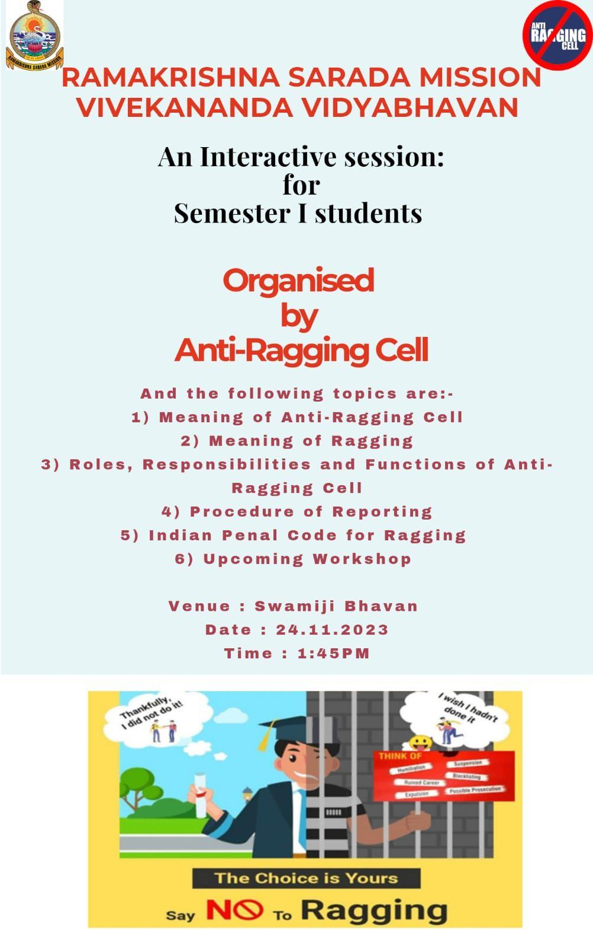

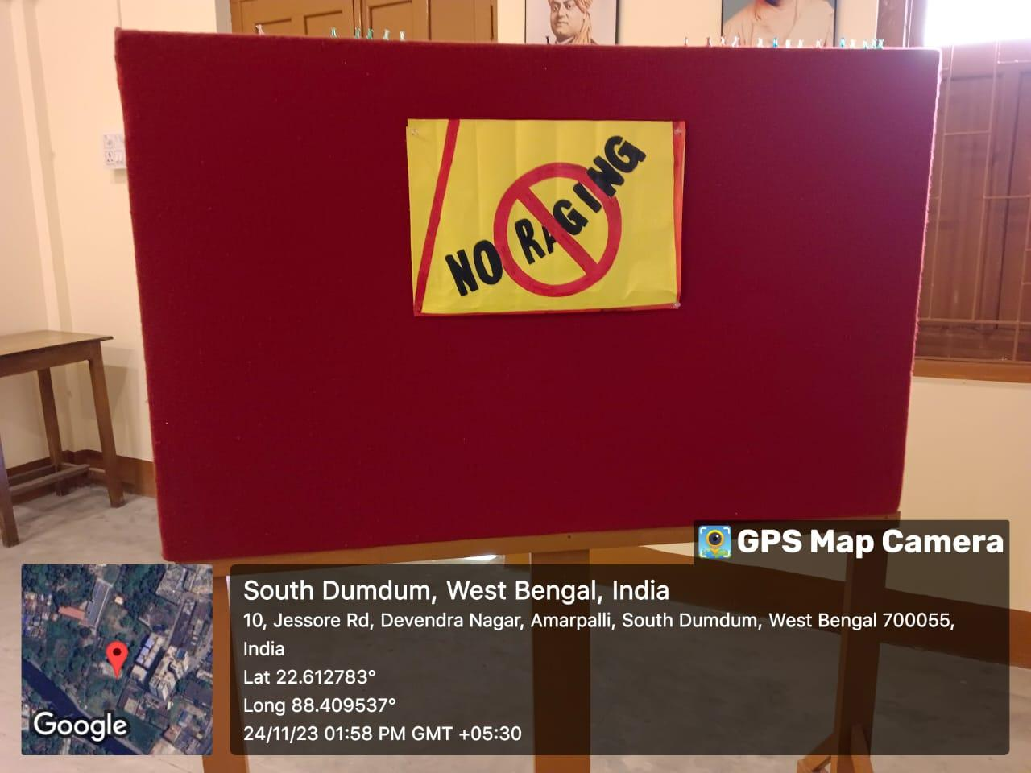

**Geo-tagged Photos**

