EXTENSION LECTURE ON 23.12.2023 FOR SEM-5

* Name of the activity : Extension Lecture
* Topic : “Concept and Methods of Research”
* Category : Departmental activity
* Organising unit : Dept. of Geography in collaboration with IQAC, RKSMVV
* Date : 23.12.2023
* Time : 11:15 am to 1:15 pm
* Venue : Geography Department class room.
* Number of Resource Person/s : 01
* Name & Designation of the Resource Person/s :

Dr. Sumana Roy,

Assistant Professor,

Department of Geography,

Kalahandi University,

Bhawanipatna, Odisha.

* Number of Participants : 16 students of SEM-5
* Brief description of the event :

This extension lecture was organised by the Geography department of RKSMVV for the students of Semester-5. The session was of two hours in duration from 11:15 am to 1:15 pm and mainly focused on the concept & methodology of research which is an important part of the syllabus (GEOACOR11T - Research Methodology & Field Work in Geography). The program started with brief introduction notes about the resource person. After that the session was handed over to the speaker. She continued her presentation for 2 hours. All the students listened to the presentation very attentively. The lecture ended with a vote of thanks to the resource person, all students, and also organising units of the department.

* Programme Outcome :

Research is an important subject in all fields of study. Research methodology gives research scientifically sound findings. The aim of research is to understand the nature of the problem. The lecture gives students the basic concept in research methodology in social science. It addresses the issues inherent in selecting a research problem and discusses the tools and techniques to be employed in completing a research project. This is also helpful for the students to use qualitative and quantitative methods of data analysis in research. Students will be able to demonstrate the ability to choose methods appropriate to research objectives and this will also enable students to prepare report writing and framing research proposals.

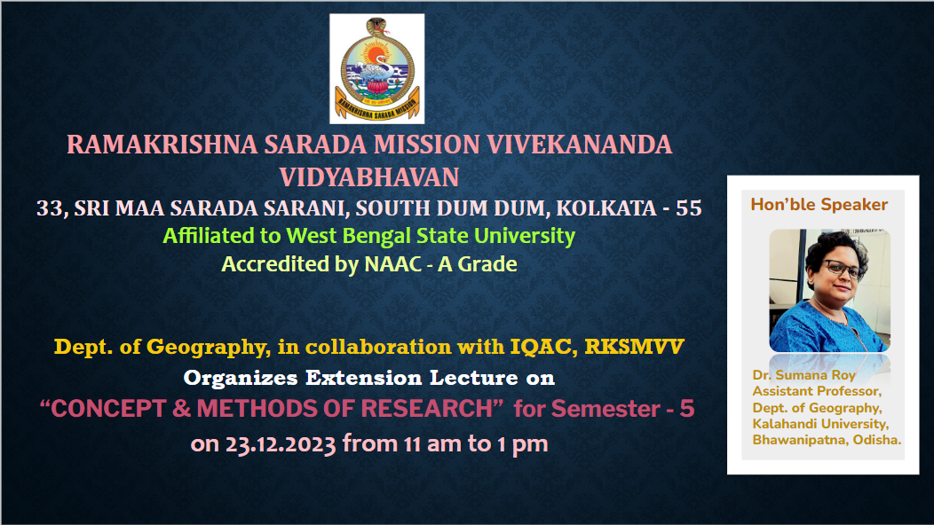

Flyer of the program

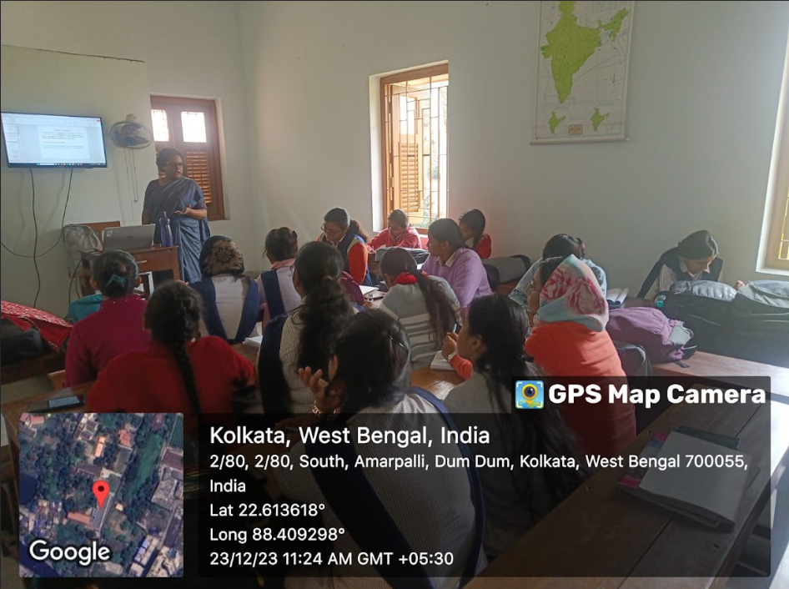

Extension lecture