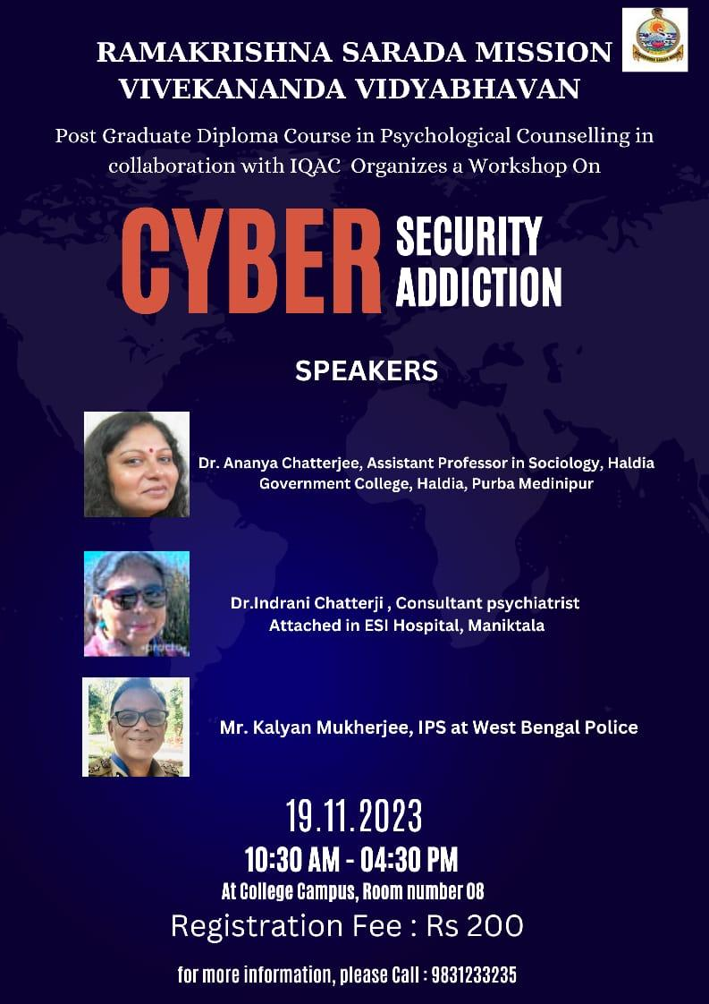

| **DEPARTMENT OF PSYCHOLOGICAL COUNSELLING**    **Name**: Cyber Security Addiction  **Category**: Workshop  **Organizing Unit:** Department of Psychological Counselling and IQAC, RKSMVV  **Date**: 19.11.2023  **Time**: 10.30 a.m.-4.30 p.m.  **Number of Students**: 35  **Number of Teachers**: 3  **Speaker:** I) Dr. Ananya Chatterjee  Assistant Professor, Department of Sociology, Haldia Government College,Purba Medinipur  II) Dr.Indrani Chatterji, Consultant Psychiatrist, Attached in ESI Hospital,Maniktala, Kolkata.  III) Mr. Priyankar Chakraborty.  **Brief Description and outcomes of the Event**: Cyber security is a very relevant issue in present era and everybody should have awareness about this. Firstly, Mr. Priyankar Chakraborty has shared his views on cyber security , where we come to know different helpline no. and websites regarding this . This session also teaches us how and when to raise complaint regarding cyber security. After this session there was a small tea break and our second speaker Dr. Indrani Chatterji presented a very valuable PowerPoint presentation on cyber addiction. Our third speaker Dr. Ananya Chatterjee delivered her lecture on social dynamics of bullying, which seems very interesting to all participants. They asked different questions and fully involved during the entire session . Lastly, a skit presentation was done by the students of PG Diploma in Psychological Counselling, where they nicely presented, how cyber security can hamper not only our privacy but also our social life. |
| --- |