FIELD TRIP TO GHATSILA FOR SEM-5
- Name of the activity : “Field Trip to Ghatsila”
- Topic : Socio-Economic Study on Ghatsila & surroundings.
- Category : Educational Field Trip
- Organising unit : Department of Geography, RKSMVV
- Date : 03.10.2023 - 6.10.2023
- Venue : Ghatsila, Jharkhand
- Number of Resource Person/s : 02
- Name of the Resource Person/s : Dr. Soma Mukhopadhyay, Ms. Kanika Das
- Number of Participants : 16 students and 2 Faculties and 1 Non-Teaching staff
- Brief description of the event : Four day Educational trip was organised by Department of Geography, Ramakrishna Sarada Mission Vivekananda Vidyabhavan, under West Bengal state University, Undergraduate Geography Students on October 3-6th,2023 to visit for Socio Economic study at village Tamakpal near Ghatsila, Dist East-Singhbhum, Jharkhand. The tour comprised students of B.Sc. Vth semester accompanied by faculty members, Prof. Dr. Soma Mukhopadhyay and Prof. Kanika Das from Dept. Of Geography. All the students were directed to gather at College gate at 5.00AM. Principal of the college Prvrajika Vedarupaprana Mataji wished all the students best and safe journey.
- Programme Outcome :
The excursion was a delightful experience for all. It was an opportunity for all to get a good geographical exposure and learn how management and marketing principles are applied by businessmen in tourist areas. Excursion was also a platform for them to get a taste of local food, understand the culture and appreciate the beauty of these cities and develop a strong bonding between each other. Students learning and enriching experience. Excursion gave students a refreshing, enlightening, adventurous, nostalgic and tremendous learning experience through visits to some of the prominent places in these destinations like Burudi dam, Subarnarekha River, Jamshedpur, Jubli park etc.

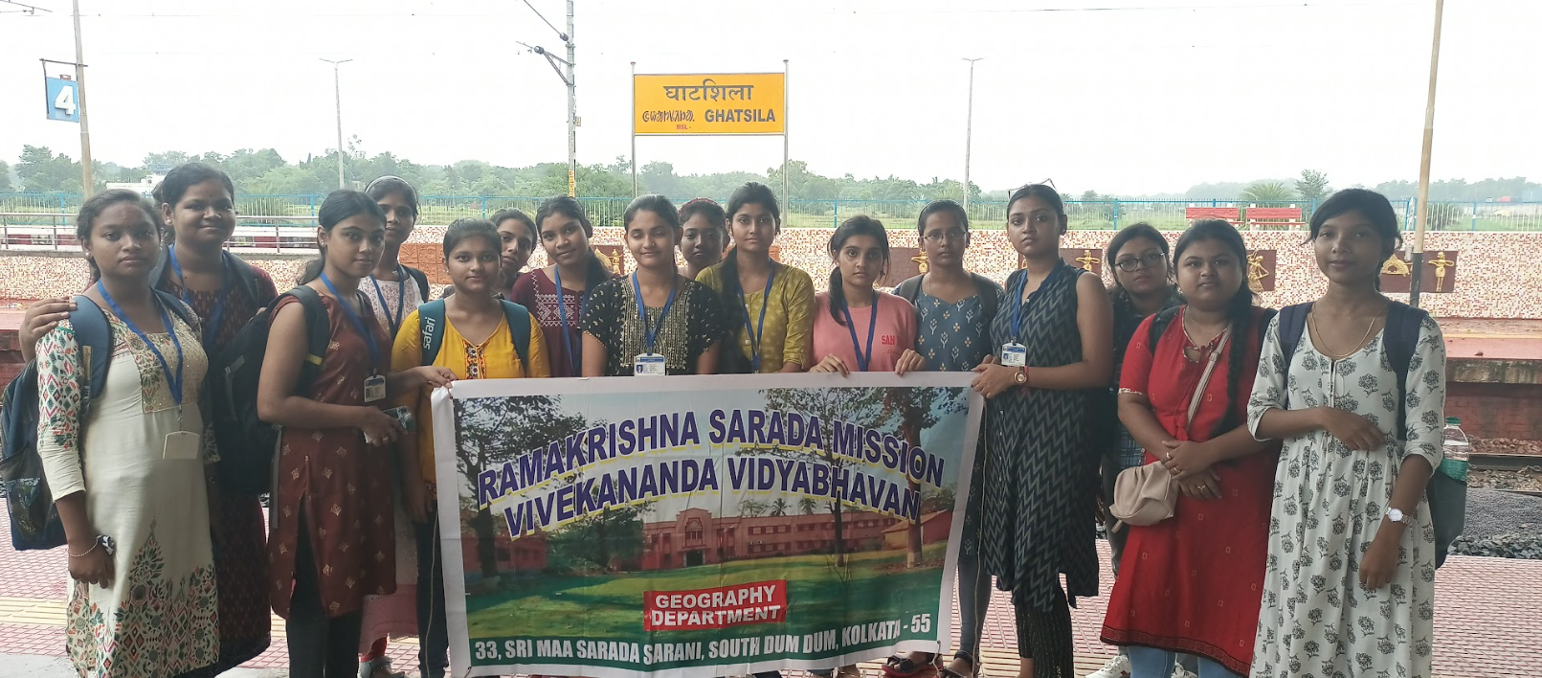
Students at Ghatsila station
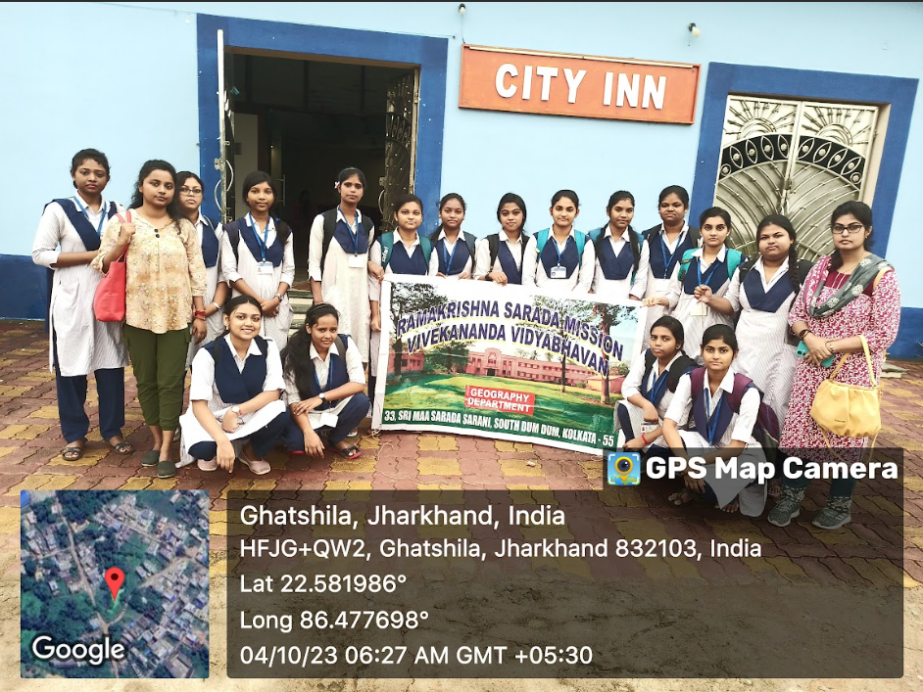
Hotel Survey
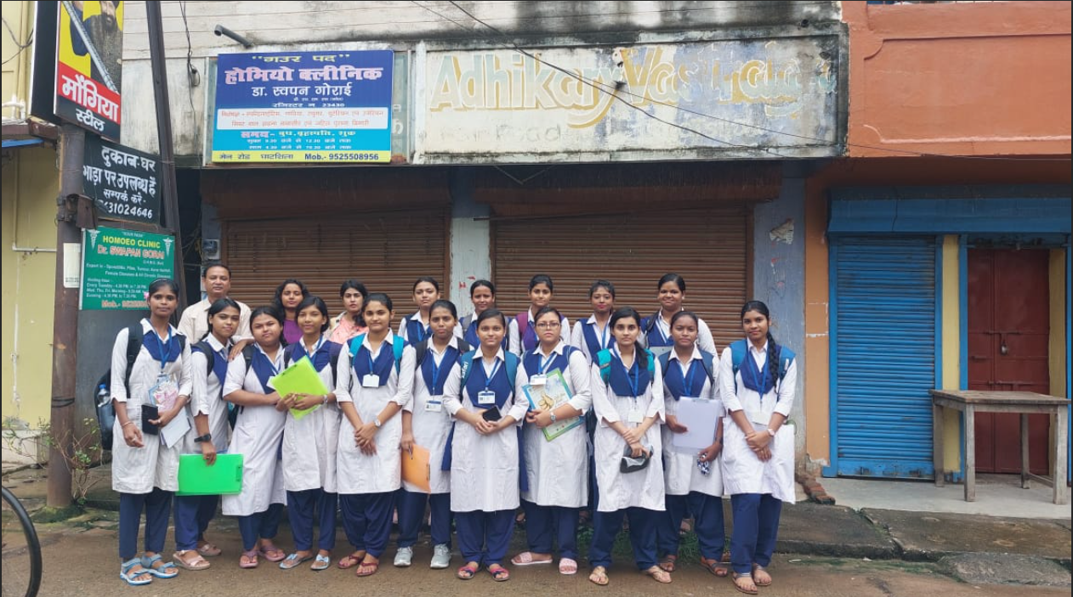
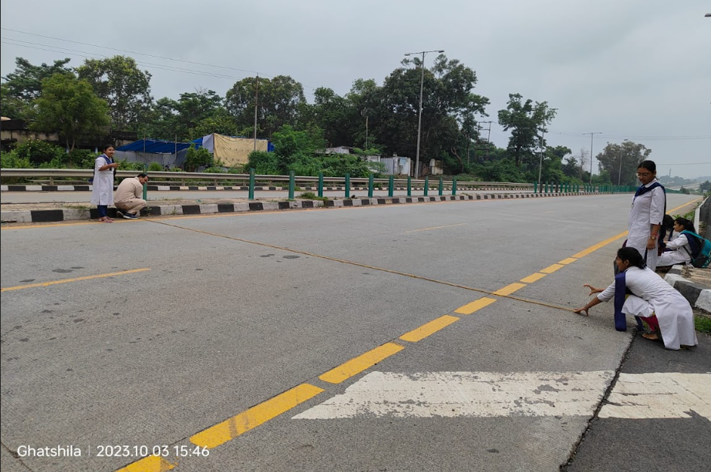
Road Survey
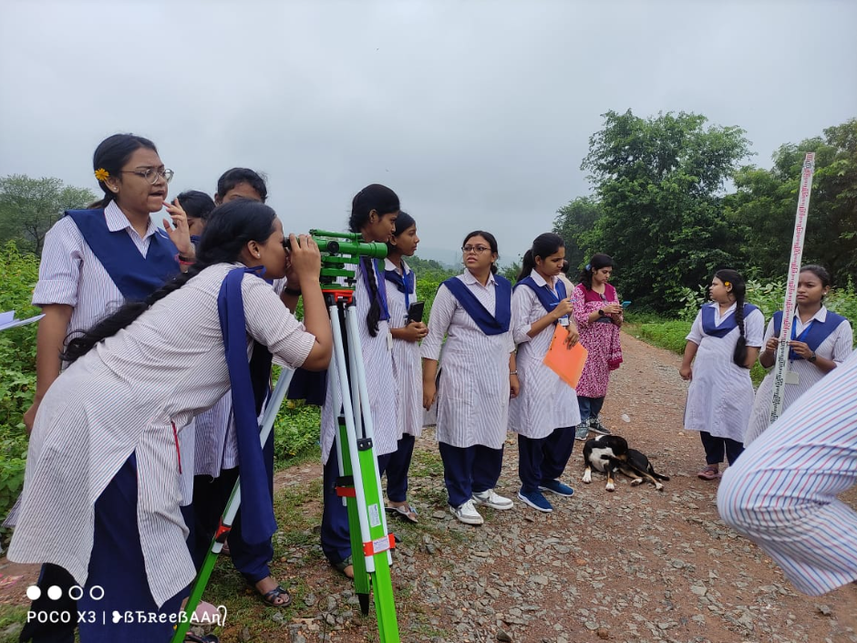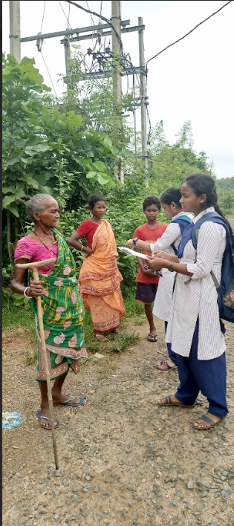
Profile Survey Household survey

