**Name of the Activity**: International Day of Democracy

**Category**: Celebration

**Topic**: Poster Presentation by the Students and Movie Screening related to Democracy

**Organizing Unit**: Department of Human Rights in Collaboration with IQAC

**Date**: 23.09.2024

**Time**: 12:15 pm to 1:15 pm

**Number of Students**: 4 (Minor, Semester I)

**Number of Teachers**: 2

**Brief Description of the Event**: The Department of Human Rights in collaboration with IQAC organized an event to celebrate International Day of Democracy through a Poster Presentation by the Students and a Movie Screening regarding “Democracy” on 23rd September 2024 from 12:15 pm to 1:15 pm. Students share their speech on “Democracy” through Poster. After completing this session, a movie has been conducted and it’s all about a 10-minute Movie which talks about deciding where to spend their holidays, a family attempts to navigate through a democratic process to determine the destination. With family members arguing over the importance of each member’s vote, they turn to making a pros and cons list to decide. However, once the family embarks on a trip an event happens that makes them question the entire Democratic process.

**Programme Outcome**:   
  
Students will:

● Identify the need to accommodate social and cultural diversity in a democracy.

● Understand how a democracy promotes acceptance of diversity.

● Appreciate that democracy forms a legal basis for the equality and dignity of all citizens.

**Flyer:**

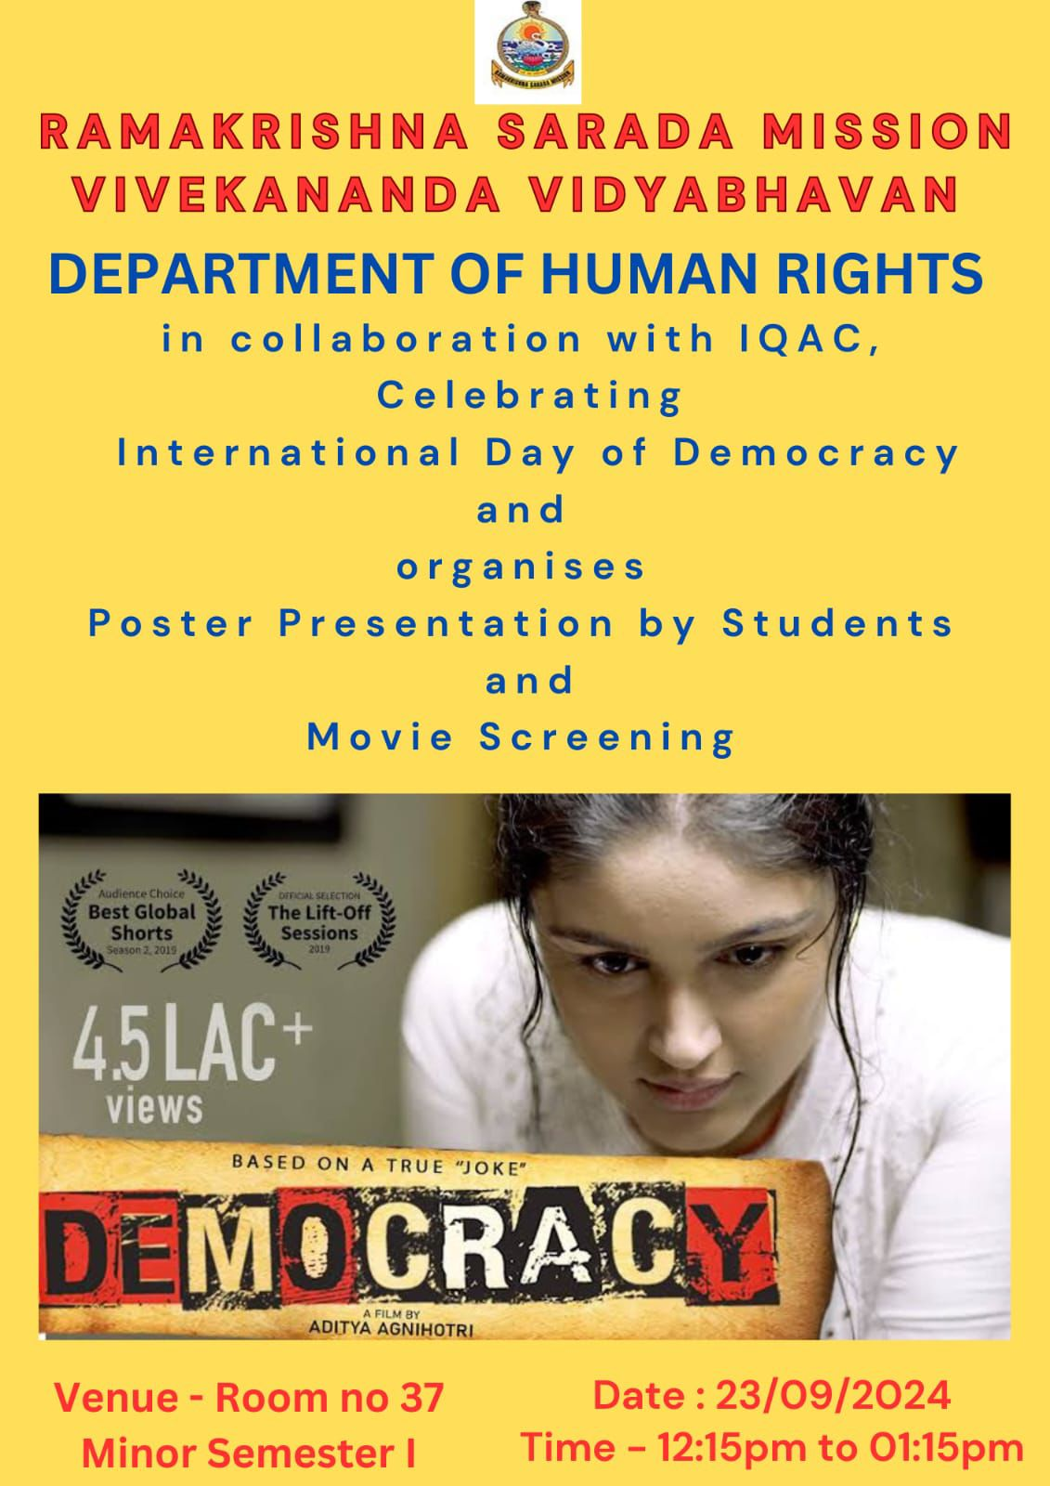

**Photos**:

