**Name of Activity:** Sexual Harassments and Discriminations faced by Women Athletes in the Field of Sports

**Category:** SeminarSeminar on Sports and Sexual Harassment

**Organising Unit:** Internal Committee, Gender Resource Centre in collaboration with the IQAC,

Ramakrishna Sarada Mission Vivekananda Vidyabhavan

**Date:** November 25, 2023

**Time:** 1:45p.m.onwards

**Venue:** Swamiji Bhavan

**Name of Resource Person/s (with Designation):**

1. Dr. Suparna Ghosh, Associate Professor, Department of History, Teacher Educator in the Department of B.Ed, Loreto College, Kolkata
2. Ms Snigdha Mondal, MA. Physical Education, (University of Calcutta) and a Gold Medallist, Assistant Teacher of Physical Education, Mitra Institution, Bhawanipur, Active National Referee (ALL INDIA FOOTBALL FEDERATION)

**Number of Participants:** 300

**Brief Description of Event :**

The programme started at 2p.m. with welcome address by Dr. Chaiti Mitra, the IQAC coordinator. The speakers enlightened the audience on the practical scenario of the issues of sexual harassments faced by women athletes in the field of sports. Dr Suparna Ghosh, in her speech, highlighted the difficulties of getting proper and concrete data regarding the sexual harassment in this domain. Her academic specialisation in the South Asian Soccer made her speech quite relevant and exposed the trauma and desperation women athletes faced in the field, coaching and from the society at large. Ms Snigdha Mondal, as an active woman athlete brought up many instances from the sports field where the female participants face lot of challenges. Some video clippings of Ms Snigdha Mondal were screened which shared some of her experiences. She encouraged the students to make career in sports not only as sportsperson but as sports officials.

**Programme Outcome:**

Both the students and the faculty have come to learn more deeply about the diverse experiences of women in the field of sports. The speeches, followed by several questions and comments, showed how enlightening a session could be. It aroused interests of both the students and the faculty in an almost non-stereotyped domain. The discussions reflected sharing of knowledge and generating empathy and a sense of power.

**Flyer:**

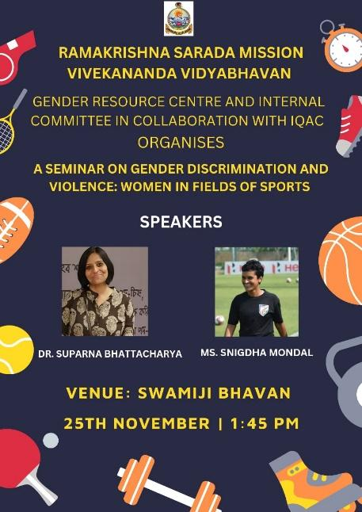 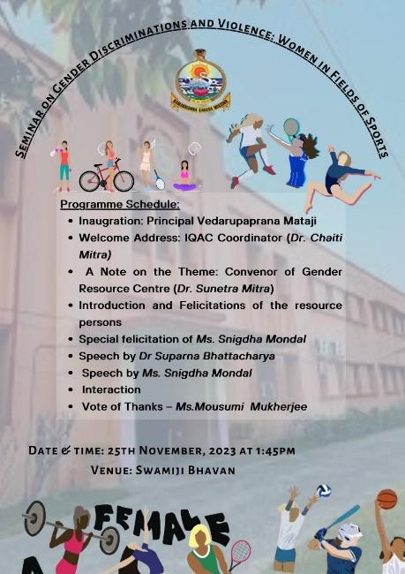

**Geo- tagged Photos**

