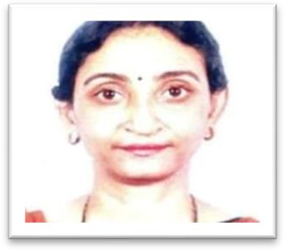

# Ms. Kasturi Mukherjee

**Designation**: (i) Faculty, RKSMVV, PG Diploma in psychological Counselling;

* 1. Faculty: Legal aid Services, Govt. of West Bengal
  2. Faculty, PG diploma course in Psychiatric Counselling, Indian psychoanalytical Society.
  3. Trainer and Counsellor at Samikshani: an organisation devoted to research and training in Psychoanalysis.

**Contact**: (i) Email: [chakrat2947@rediffmail.com](mailto:chakrat2947@rediffmail.com)

(ii) Mobile: +919831275131

**Qualification**: (i) M.A. Economics, RBU, 1992.

1. M.A, Applied Psychology, Annamalai University, 2010;
2. B. Ed. (CU), 1994;
3. Post-graduate Diploma in Psychological Counselling offered by Samikshani: an organisation for research and teaching of psychoanalysis, 2003;
4. Diploma in social Work and Community Development, National Council of Education, JU, 2004;
5. Certificate based experiential sessions on NLP and Creative Art Therapy, 2018;
6. Training of Trainers Programme, Samikshani, 2011;
7. Basic and advanced course in Graphology, 2015;
8. Play Therapy advanced Course, Samikshani, 2006;
9. Modern Trauma Therapy< Indian Psychoanalytical society, 2010;
10. Refresher course on Training of Trainers, Samikshani, 2019;
11. Telecounselling, Indian psychoanalytical Society, 2020.

**Teaching Experience**: (i) Guest lecturer of Economics at Victoria Institution for seven years.

1. Teaching training programmes at Legal Aid Services, affiliated to Calcutta University;
2. Teaching at the PG diploma Course at Indian Psychoanalytical Society.

# Academic work: 2022 – 2024:

**2023**

* 22/01 participated in Pannel discussion on ‘Graphology as a tool for

psycho-diagnostics testing’ at Kolkata Institute of Graphology

* 25.03. Conducted mental health awareness camp held at RSMVV on
* June: Talk on ‘Exam anxiety and its remedial measures ’ at Gurudas

college 21/06

* 06/10 Seminar on ‘Stress and wellbeing” at Antara Mental Hospital
* 10/10: Seminar at Tara Devi Harakh Chand Kankaria Jain College on

‘Abuse, Violence and Mental Health in daily life’;

* Talk at Monohor Academy school on Exam anxiety 13/10

# 2024

* June: ‘Value education – its impact on young minds’ at A K Mitra

Institution for girls on 28/06

* Conducted Play therapy and few other skills based sessions at IPS
* Attended monthly visits at Gurudas college and Acharya Girish Chandra Bose College for individual counselling session
* Attended monthly visits to Udbhas Spastic Welfare society to conduct interactive sessions
* Gender sensitivity workshop with teenager and adlolescent boys and girls with Hijli Inspiration at Kamarhati
* Staff counselling programme at ANJALI on behalf of Samikshani.